# PROGRAMING LANGUAGE

**Program:** Program is the chain of step to do a work.

**Programing language:** programming language is some syntax which help the program run.

**Type of program:**

1. Low Level: low level programing language directly interact with machine hardware. machine language, assembly language (add, store, load).
2. High Level: high level language writes in human language but convert into machine language. Java, C++, COBAL.

**Complier:** A compiler is a special program that translates a programming language's source code into machine code, bytecode, or another programming language.  The source code is typically written in a high-level, human-readable language such as Java or C++. A programmer writes the source code in a code editor or an integrated development environment (IDE) that includes an editor, saving the source code to one or more text files. Compilers that translate source code to machine code target specific operating systems and computer architectures.

**Interpreter:** Compilers are sometimes confused with programs called interpreters. Although the two are similar, they differ in important ways. Interpreters do not generate IR code or save generated machine code. They process the code one statement at a time at runtime, without pre-converting the code or preparing it in advance for a particular platform. Interpreters are used for code written in scripting languages such as Perl, PHP, Ruby, or Python.

**Approach to develop a software programing language –**

1. Procedural oriented: C
2. Object oriented: Simula, C++, java
3. Aspect oriented: Java spring,

**Object based divided:**

* + - 1. Object oriented
      2. Object based
      3. Pure object

**Platform:**

1. platform is the place or a runtime environment on which our program is going to be execute.
2. Any hardware or software environment in which a program runs, is known as a platform.
3. Since Java has a runtime environment (JRE) and API, it is called a platform.

**Platform Type:**

1. Software platform
2. Hardware platform
3. Combination of both
4. **Source code :** The code writes in human language and save is called source code.
5. **Object code** : After compiler the code make that called object code.
6. **Explicit:** which in can be explained called explicit
7. **Implicit:** which cannot be explained but can be understand by logic is called implicit. If x>y and y>z then x>z we know by logic. Is called implicit

**How C / C++ program run in computer:**

First, we write a C/C++ source code . then compiler, compile it with GCC (GNU Compiler Collections)/TCC (turbo c compiler). Compiler called the O.S library and convert all code to object code.

But now in windows, compiler convert source code in **exc** file. In **exc** file add necessary O.S file at compiler time. So, there is no need for create object file. This **exc** file only run-in windows.

**32bit:** 32-bit, in computer systems, refers to the number of bits that can be transmitted or processed in parallel. In computer architecture, 32-bit integers, memory addresses, or other data units are those that are 32 bits (4 octets) wide.

**64bit:** In computer architecture, 64-bit integers, memory addresses, or other data units are those that are 64 bits wide.

**How run java:** In java, when program compile source code does not interact with hardware. Compiler run JRE platform and make byte code. Then JVM read byte code and attach with hardware.

# JAVA

**What is java:**

Java is a programming language and a **platform**. Java is a high level, robust, platform independent, object-oriented, and secure programming language. Java was developed by Sun Microsystems (which is now the subsidiary of Oracle) in the year 1995.

**Java feature:**

1. Simple
2. Secure
3. Platform independent
4. Robust
5. Architecture Neutral: Java run any type of hardware architecture.
6. Multithread:
7. Distributed: Java can create distribute software. Distribute software are RMI, EJB, Web service.
8. Dynamic:
9. No Explicit pointer: we can excess the address of dynamic memory but cannot excess by * or & .
10. Automatic Garbage collector.

## Types of Java Applications:

1. **Standalone Application:** Standalone applications are also known as desktop applications or window-based applications. These are traditional software that we need to install on every machine. Examples of standalone application are Media player, antivirus, etc. AWT and Swing are used in Java for creating standalone applications.
2. **Web Application:** An application that runs on the server side and creates a dynamic page is called a web application. Servlet , JSP , Struts , Spring , Hibernate, JSF.
3. **Enterprise Application:** An application that is distributed in nature, such as banking applications, etc. is called an enterprise application. It has advantages like high-level security, load balancing, and clustering. In Java, EJB is used for creating enterprise applications.
4. **Mobile Application:** An application which is created for mobile device is called a mobile application. Currently, Android and Java ME are used for creating mobile applications.

## There are 4 platforms or editions of Java

1. **Java SE (Java Standard Edition):** It is a Java programming platform. It includes Java programming APIs such as java.lang , java.io, java.net, java.util , java.sql, java. Math etc. It includes core topics like OOPs, String, Regex, Exception, Inner classes, Multithreading, I/O Stream, Networking, AWT, Swing, Reflection, Collection, etc.
2. **Java EE (Java Enterprise Edition):** It is an enterprise platform that is mainly used to develop web and enterprise applications. It is built on top of the Java SE platform. It includes topics like Servlet, JSP, Web Services, EJB, JPA, etc.
3. **Java ME (Java Micro Edition):** It is a micro platform that is dedicated to mobile applications.
4. **JavaFX:** It is used to develop rich internet applications. It uses a lightweight user interface API.

## Java Version History

1. **JDK Alpha and Beta (1995):** The Java Alpha and Beta was the first releases, but they have highly unstable APIs and ABIs. The supplied Java web browser was named Web Runner.
2. **JDK 1.0 (January 23, 1996):** It was the first stable released version of Java. Its codename was **Oak**. The first stable version of JDK was JDK 1.0.2 and it was called Java 1. Up to JDK 1.0.1, private and protected keywords could be used together to create yet another form of protection which used to act as a restriction to methods or variables mainly to subclasses of a given class. In JDK 1.0.2, this capability has been removed.
3. **JDK 1.1 (February 19, 1997):** Some additions were included to this version. i.e.
4. The concept of Inner Class
5. JavaBeans
6. JDBC
7. RMI
8. AWT event model was totally reshaped.
9. Reflection (which supported Introspection only, modification was not possible at runtime).
10. JIT(Just In Time) compiler on Microsoft Windows platforms, produced for Java Soft by Symantec Internationalization
11. Unicode support originating from Telligent.
12. **J2SE 1.2 (December 8, 1998):**Its codename was **Playground**. First time, it was called **J2SE (Java 2 Platform, Standard Edition). It** replaced JDK to recognize the base platform from **J2EE (Java 2 Platform, Enterprise Edition) and J2ME (Java 2 Platform, Micro Edition)**.It was a very important java release as it tripled the size of the Java platform to 1520 classes in 59 packages.

Some additions were included to this version. i.e.

* + 1. Java plug-in
    2. Java IDL, an IDL implementation for CORBA interoperability
    3. Collection’s framework
    4. the Swing graphical API was integrated into the core classes

1. **J2SE 1.3 (May 8, 2000):** Its code name was **Kestrel**. Some additions were included to this version. i.e.
2. HotSpot JVM included.
3. RMI was modified to support optional compatibility with CORBA.
4. JNDI (Java Naming and Directory Interface).
5. Java Platform Debugger Architecture (JPDA) included.
6. JavaSound.
7. Synthetic proxy classes.
8. **J2SE 1.4 (February 6, 2002):** Its codename was **Merlin**. It was the first Java platform which was released under the Java Community Process. Some additions were included to this version. i.e.
9. Improved libraries.
10. Perl regular expressions included.
11. Provided exception chaining (It allows an exception to encapsulate original lower-level exception).
12. IPv6 support (Internet Protocol version 6).
13. Logging API (Specified in JSR 47.)
14. Image I/O API for reading and writing images in formats like JPEG and PNG.
15. XML parser and XSLT processor integrated.
16. Security and cryptography extensions (JCE, JSSE, JAAS) integrated.
17. Support and security updates for Java 1.4 ended in October 2008.
18. **J2SE 5.0 (September 30, 2004):** Its codename was Tiger. It was originally numbered 1.5, which is still used as the internal version number. So, it was changed to 5.0 to "better reflect the level of maturity, stability, scalability and security of the J2SE". This process also was released under the Java Community Process. Support and security updates for Java 5.0 ended on November 3, 2009, but updates were available to paid Oracle customers until May 2015. J2SE 5.0. added some significant new language features:

It provided compile-time (static) type safety for collections and eliminates the need for most typecasts.

1. Used Metadata or annotations.
2. Autoboxing/unboxing.
3. Enumerations.
4. Enhanced for each loop.
5. Improved semantics of execution for multi-threaded Java programs.
6. Static imports.

There were also some improvements in standard libraries:

1. Automatic stub generation for RMI objects.
2. Swing: It provided a skinny look and feel.
3. The concurrency utilities in package java.util.concurrent.
4. Scanner class for parsing data from various input streams and buffers.
5. Java 5 was the last release of Java which officially supported the Microsoft Windows 9x line (Windows 95, Windows 98, Windows ME).
6. Windows Vista was the last version of Windows that J2SE 5 supported before going to end in October 2009.
7. Java 5.0 is the default version of Java installed on Apple Mac OS X 10.5 (Leopard). Java 6 can be installed
8. **Java SE 6 (December 11, 2006):** Its codename was **Mustang**. After the release of this version, Java replaced the name J2SE to Java SE and dropped the .0 from the version number. Some additions were included to this version. i.e.
9. Dropped the support for older Win9x versions.
10. Scripting Language Support.
11. Generic API for tight integration with scripting languages.
12. Improved Web Service support.
13. JDBC 4.0 support.
14. Use a Java Compiler API to invoke a Java Compiler programmatically.
15. After the release of Java 6, Sun released many updates to fix bugs.
16. **Java SE 7 (July 28, 2011):** Its codename was Dolphin. It was launched on 7, July 2011 but was made available for developers on July 28, 2011.
17. JVM support for dynamic languages.
18. Compressed 64-bits pointer.
19. Strings added in switch.
20. Automatic resource management in try-statement.
21. Underscores allowed in numeric literals.
22. Binary integer literals.
23. Improved type interface for creating generic instance. (also called diamond operator <>)
24. Improved catching and throwing. (catch multiple exceptions and rethrow with improved type checking)
25. Provided Java Deployment rulesets.
26. It was the default version to download on java.com from April 2012 up to the release of Java 8.
27. **Java SE 8 (March 18, 2014):** its codename was **Spider**. Although, codenames have been discontinued, but the codename **Spider** is common among java developers. It includes some features which were proposed for Java SE 7 but added in Java SE 8.
28. Language-level support for Lambda expressions.
29. Allowed developers to embed JavaScript code within applications.
30. Annotation of Java Types.
31. Provided Date and Time API.
32. Repeating Annotations.
33. Launching of JavaFX applications.
34. Removal of permanent generation.
35. Java 8 is set as a default version to download from java.com from October 2014.
36. **Java SE 9 (September 21, 2017):** In 2016, Oracle discussed some features to release in Java 9. It was hoped that Java 9 would include better support for multi-gigabyte heaps, better native code integration, a different default garbage collector and a self-tuning JVM. The release of Java 9 was postponed many times and finally it was released on September 21, 2017.
37. Modularization of the JDK under Project Jigsaw.
38. Provided Money and Currency API.
39. Tight integration with JavaFX.
40. Java implementation of reactive streams.
41. More Concurrency Updates.
42. Provided Java Linker.
43. Automatic scaling and sizing.
44. **Java SE 10 (March, 20, 2018):** Java SE 10 was released to remove primitive data types and move towards 64-bit addressable arrays to support large data sets. It was released on 20 March 2018, with twelve new features confirmed. These features are:
45. Local-Variable Type Inference
46. Experimental Java-Based JIT Compiler This is the integration of the Graal dynamic compiler for the Linux x64 platform
47. Application Class-Data Sharing This allows application classes to be placed in the shared archive to reduce startup and footprint for Java applications
48. Time-Based Release Versioning
49. Parallel Full GC for G1
50. Garbage-Collector Interface
51. Additional Unicode Language-Tag Extensions
52. Root Certificates
53. Thread-Local Handshakes
54. Heap Allocation on Alternative Memory Devices
55. Remove the Native-Header Generation Tool - javah
56. Consolidate the JDK Forest into a Single Repository

## Java Architecture

Java Architecture is a collection of components, i.e., JVM, JRE, and JDK. It integrates the process of interpretation and compilation. It defines all the processes involved in creating a Java program. Java Architecture explains every step of how a program is compiled and executed. Java Architecture can be explained by using the following steps: There is a process of compilation and interpretation in Java. Java compiler converts the Java code into byte code. After that, the JVM converts the byte code into machine code. The machine code is executed by the machine.

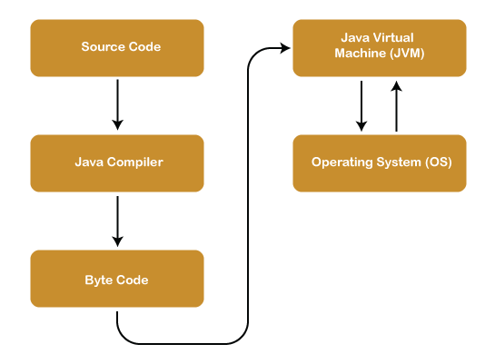

Now let's dive deep to get more knowledge about **Java Architecture**. As we know that the Java architecture is a collection of components, so we will discuss every component into detail.

**Components of Java Architecture:** The Java architecture includes the three main components:

1. **Java Virtual Machine (JVM)**
2. **Java Runtime Environment (JRE)**
3. **Java Development Kit (JDK)**
4. **Java Virtual Machine(JVM):** The main feature of Java is **Write Once Run Anywhere(WORA)**. The feature states that we can write our code once and use it anywhere or on any operating system. Our Java program can run any of the platforms only because of the Java Virtual Machine. It is a Java platform component that gives us an environment to execute java programs. JVM's main task is to convert byte code into machine code. JVM, first, loads the code into memory and verifies it. After that, it executes the code and provides a runtime environment. Java Virtual Machine (JVM) has its own architecture, which is given below:
5. **JVM Architecture:** JVM is an abstract machine that provides the environment in which Java bytecode is executed. The falling figure represents the architecture of the JVM.

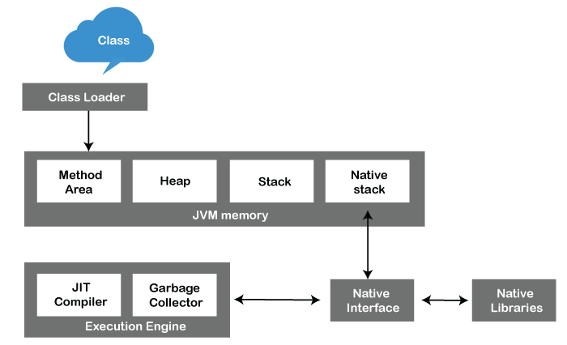

1. **Class Loader:** ClassLoader is a subsystem used to load class files. ClassLoader first loads the Java code whenever we run it
2. **Class Method Area:** In the memory, there is an area where the class data is stored during the code's execution. Class method area holds the information of static variables, static methods, static blocks, and instance methods.
3. **Heap:**  The heap area is a part of the JVM memory and is created when the JVM starts up. Its size cannot be static because it increases or decrease during the application runs.
4. **Stack:** It is also referred to as thread stack. It is created for a single execution thread. The thread uses this area to store the elements like the partial result, local variable, data used for calling method and
5. returns etc.
6. **Native Stack:** It contains the information of all the native methods used in our application.
7. **Execution Engine:** It is the central part of the JVM. Its main task is to execute the byte code and execute the Java classes. The execution engine has three main components used for executing Java classes.
8. **Interpreter:** It converts the byte code into native code and executes. It sequentially executes the code. The interpreter interprets continuously and even the same method multiple times. This reduces the performance of the system, and to solve this, the JIT compiler is introduced.
9. **JIT Compiler:** JIT compiler is introduced to remove the drawback of the interpreter. It increases the speed of execution and improves performance.
10. **Garbage Collector:** The garbage collector is used to manage the memory, and it is a program written in Java. It works in two phases, i.e., **Mark** and **Sweep**. Mark is an area where the garbage collector identifies the used and unused chunks of memory. The Sweep removes the identified object from the **Mark**
11. **Java Native Interface:** Java Native Interface works as a mediator between Java method calls and native libraries.
12. **Java Runtime Environment(JRE):** It provides an environment in which Java programs are executed. JRE takes our Java code, integrates it with the required libraries, and then starts the JVM to execute it. JRE (Java Runtime Environment) is a software package that provides Java class libraries, Java Virtual Machine (JVM), and other components that are required to run Java applications is the superset of JVM. If you need to run Java programs, but not develop them, JRE is what you need. You can download JRE from Java SE Runtime Environment 8 Down.

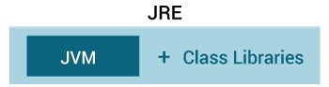

Java Runtime Environment

1. **Java Development Kit:** It is a software development environment used in the development of Java applications and applets. Java Development Kit holds JRE, a compiler, an interpreter or loader, and several development tools in it. JDK (Java Development Kit) is a software development kit required to develop applications in Java. When you download JDK, JRE is also downloaded with it.In addition to JRE, JDK also contains a number of development tools (compilers, JavaDoc, Java Debugger, etc.)



**Relationship between JVM, JRE, and JDK.**

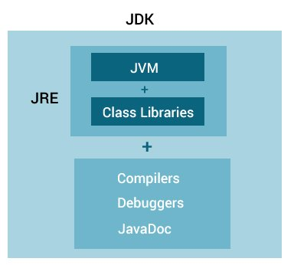

**Java run:**

1. With IDE: With IDE all programing necessary environment setup perfectly. So we do not need anything. Eclipse, NetBeans.
2. Without IDE: Without IDE we need compiler, library, run environment, editor.

# VARIABLES IN JAVA

1. A variable is a container which holds the value while the Java program is executed.
2. A variable is assigned with a data type.
3. Variable is a name of memory location

There are 3 types of variables in Java programming language:

1. Local Variables
2. Instance Variables (Non-Static Fields)
3. Static Variables (class Fields)

**1)Local Variable:**

1. A variable declared inside the declared method, constructor, or block is called local variable.
2. Local variables are visible only within the declared method, constructor, or block.
3. A local variable cannot be defined with "static" keyword.
4. There is no default value for local variables, so local variables should be declared and an initial value should be assigned before the first use.

**public class Test**

**{**

**public void pupAge() {**

**int age = 0 ; //// local variable**

**age = age + 7;**

**System.out.println("Puppy age is : " + age);**

**}**

**public static void main(String args[]) {**

**Test pet = new Test();**

**pet.pupAge();**

**}**

**}**

**2) Instance Variable:**

1. A variable declared inside the class but outside the body of the method, is called an instance variable.
2. It is not declared as static.
3. It is called an instance variable because its value is instance-specific and is not shared among instances.
4. The instance variables are visible for all methods, constructors, and block in the class.
5. Instance Variable can be used only by creating objects
6. Instance variables have default values. For numbers, the default value is 0, for Booleans it is false, and for object references it is null. Values can be assigned during the declaration or within the constructor.

**public class Employee**

**{**

**public String name; /instance variable**

**private double salary;**

**public Employee (String empName) {**

**name = empName;**

**}**

**public void setSalary(double empSal) {**

**salary = empSal;**

**}**

**}**

**3) Static variable/class variable:**

1. A variable that is declared as static is called a static variable.
2. It cannot be local.
3. You can create a single copy of the static variable and share it among all the instances of the class.
4. Memory allocation for static variables happens only once when the class is loaded in the memory.
5. Default values are same as instance variables. For numbers, the default value is 0; for Booleans, it is false; and for object references, it is null. Values can be assigned during the declaration or within the constructor. Additionally, values can be assigned in special static initializer blocks.

**public class Employee{**

**private static double salary;**

**public static final String DEPARTMENT = "Development "; /static variable**

**public static void main(String args[]) {**

**salary = 1000;**

**System.out.println(DEPARTMENT + "average salary:" + salary);**

**}**

**}**

# DATA TYPES

Data types specify the different sizes and values that can be stored in the variable. There are two types of data types in Java:

1. **Primitive data types:**
2. **Non-primitive data types**

**JAVA PRIMITIVE DATA TYPES:**

1. In Java language, primitive data types are the building blocks of data manipulation.
2. All variables must be declared before its use.
3. we need to declare variable's type and name.

primitive data types list:

1. Boolean: false 1 bit
2. Char : 2 bytes
3. Byte : 1 byte
4. Short: 2 bytes
5. Int : 4 bytes
6. Long: 8 bytes
7. Float : 4 bytes
8. Double : 8 bytes

**JAVA NON-PRIMITIVE DATA TYPES:**

1. Arrays.
2. Classes
3. Interfaces

## Literals in Java

Any constant value which can be assigned to the variable is called literal/constant.

int x = 100; // A literal ‘100’ represents the value 100.

1. Integral literals:
2. Floating-Point literal : Floating-point literals can be expressed using only decimal fractions or as exponential notation.
3. Char literals: Character (Char) literals have the type char and are an unsigned integer primitive type.
4. String literals: A sequence of (zero or more including Unicode characters) characters within double quotes is referred to as string literals.
5. Boolean literals: Boolean literals allow only two values and thus are divided into two literals:
   * + 1. True: it represents a real Boolean value
       2. False: it represents a false Boolean value
6. Null Literals : Null literal is a particular literal in Java representing a null value

## TYPE CONVERTION

It is the process of converting one type of data into another type .

**Widening / Type Promotion (implicit):**

Converting a lower datatype to a higher datatype is known as widening. In this case the casting/conversion is done automatically therefore, it is known as implicit type casting. In this case both datatypes should be compatible with each other.

**public class WideningExample {**

**public static void main(String args[]){**

**char ch = 'C';**

**int i = ch;**

**System.out.println(i);**

**}**

**}**

**Narrowing / Type Casting ( Explicit ) :**

Converting a higher datatype to a lower datatype is known as narrowing. In this case the casting/conversion is not done automatically, you need to convert explicitly using the cast **operator “( )”** explicitly. Therefore, it is known as explicit type casting. In this case both datatypes need not be compatible with each other.



**public class** **NarrowingExample** {

**public static void** **main**(String args[]){

**Scanner** sc = new Scanner(System.in);

**System**.out.println("Enter an integer value: ");

**int** i = sc.nextInt();

**char** ch = (char) i ;

**System**.out.println( ch );

   }

}

# FUNDAMENTAL

## Operators in Java ----- 106

Operator in Java is a symbol that is used to perform operations. For example: +, -, *, / etc. There are many types of operators in Java which are given below:

1. Unary Operator,
2. Arithmetic Operator,
3. Shift Operator,
4. Relational Operator,
5. Bitwise Operator,
6. Logical Operator,
7. Ternary Operator and
8. Assignment Operator.

**Java Operator Precedence:**

|  |  |  |
| --- | --- | --- |
| Operator Type | Category | Precedence |
| Unary | postfix | expr++ expr-- |
| prefix | ++expr --expr +expr -expr ~ ! |
| Arithmetic | multiplicative | * / % |
| additive | + - |
| Shift | shift | << >> >>> |
| Relational | comparison | < > <= >= instance of |
| equality | == != |
| Bitwise | bitwise AND | & |
| bitwise exclusive OR | ^ |
| bitwise inclusive OR | | |
| Logical | logical AND | && |
| logical OR | || |
| Ternary | ternary | ? : |
| Assignment | assignment | = += -= *= /= %= &= ^= |= <<= >>= >>>= |

Operator overload:

Some operator uses in various purpose. As like + operator use in integer as add , but in string it uses as concatenation.

## List of Java Keywords

A list of Java keywords or reserved words are given below:

1. [**abstract**](https://www.javatpoint.com/abstract-keyword-in-java)**:** Java abstract keyword is used to declare an abstract class. An abstract class can provide the implementation of the interface. It can have abstract and non-abstract methods.
2. [**boolean:**](https://www.javatpoint.com/boolean-keyword-in-java) Java boolean keyword is used to declare a variable as a boolean type. It can hold True and False values only.
3. [**break**](https://www.javatpoint.com/java-break)**:** Java break keyword is used to break the loop or switch statement. It breaks the current flow of the program at specified conditions.
4. [**byte**](https://www.javatpoint.com/byte-keyword-in-java)**:** Java byte keyword is used to declare a variable that can hold 8-bit data values.
5. [**case**](https://www.javatpoint.com/case-keyword-in-java)**:** Java case keyword is used with the switch statements to mark blocks of text.
6. [**catch**](https://www.javatpoint.com/try-catch-block)**:** Java catch keyword is used to catch the exceptions generated by try statements. It must be used after the try block only.
7. [**char**](https://www.javatpoint.com/char-keyword-in-java)**:** Java char keyword is used to declare a variable that can hold unsigned 16-bit Unicode characters
8. [**class**](https://www.javatpoint.com/class-keyword-in-java)**:** Java class keyword is used to declare a class.
9. [**continue**](https://www.javatpoint.com/java-continue)**:** Java continue keyword is used to continue the loop. It continues the current flow of the program and skips the remaining code at the specified condition.
10. [**default**](https://www.javatpoint.com/default-keyword-in-java)**:** Java default keyword is used to specify the default block of code in a switch statement.
11. [**do**](https://www.javatpoint.com/java-do-while-loop)**:** Java do keyword is used in the control statement to declare a loop. It can iterate a part of the program several times.
12. [**double**](https://www.javatpoint.com/double-keyword-in-java)**:** Java double keyword is used to declare a variable that can hold 64-bit floating-point number.
13. [**else**](https://www.javatpoint.com/java-if-else)**:** Java else keyword is used to indicate the alternative branches in an if statement.
14. [**enum**](https://www.javatpoint.com/enum-in-java)**:** Java enum keyword is used to define a fixed set of constants. Enum constructors are always private or default.
15. [**extends**](https://www.javatpoint.com/inheritance-in-java)**:** Java extends keyword is used to indicate that a class is derived from another class or interface.
16. [**final**](https://www.javatpoint.com/final-keyword)**:** Java final keyword is used to indicate that a variable holds a constant value. It is used with a variable. It is used to restrict the user from updating the value of the variable.
17. [**finally**](https://www.javatpoint.com/finally-block-in-exception-handling)**:** Java finally keyword indicates a block of code in a try-catch structure. This block is always executed whether an exception is handled or not.
18. [**float**](https://www.javatpoint.com/float-keyword-in-java)**:** Java float keyword is used to declare a variable that can hold a 32-bit floating-point number.
19. [**for**](https://www.javatpoint.com/java-for-loop)**:** Java for keyword is used to start a for loop. It is used to execute a set of instructions/functions repeatedly when some condition becomes true. If the number of iteration is fixed, it is recommended to use for loop.
20. [**if**](https://www.javatpoint.com/java-if-else)**:** Java if keyword tests the condition. It executes the if block if the condition is true.
21. [**implements**](https://www.javatpoint.com/interface-in-java)**:** Java implements keyword is used to implement an interface.
22. [**import**](https://www.javatpoint.com/package)**:** Java import keyword makes classes and interfaces available and accessible to the current source code.
23. [**instanceof**](https://www.javatpoint.com/downcasting-with-instanceof-operator)**:** Java instanceof keyword is used to test whether the object is an instance of the specified class or implements an interface.
24. [**int**](https://www.javatpoint.com/int-keyword-in-java)**:** Java int keyword is used to declare a variable that can hold a 32-bit signed integer.
25. [**interface**](https://www.javatpoint.com/interface-in-java)**:** Java interface keyword is used to declare an interface. It can have only abstract methods.
26. [**long**](https://www.javatpoint.com/long-keyword-in-java)**:** Java long keyword is used to declare a variable that can hold a 64-bit integer.
27. **native:** Java native keyword is used to specify that a method is implemented in native code using JNI (Java Native Interface).
28. [**new**](https://www.javatpoint.com/new-keyword-in-java)**:** Java new keyword is used to create new objects.
29. [**null**](https://www.javatpoint.com/null-keyword-in-java)**:** Java null keyword is used to indicate that a reference does not refer to anything. It removes the garbage value.
30. [**package**](https://www.javatpoint.com/package)**:** Java package keyword is used to declare a Java package that includes the classes.
31. [**private**](https://www.javatpoint.com/private-keyword-in-java)**:** Java private keyword is an access modifier. It is used to indicate that a method or variable may be accessed only in the class in which it is declared.
32. [**protected**](https://www.javatpoint.com/protected-keyword-in-java)**:** Java protected keyword is an access modifier. It can be accessible within the package and outside the package but through inheritance only. It can't be applied with the class.
33. [**public**](https://www.javatpoint.com/public-keyword-in-java)**:** Java public keyword is an access modifier. It is used to indicate that an item is accessible anywhere. It has the widest scope among all other modifiers.
34. [**return**](https://www.javatpoint.com/return-keyword-in-java)**:** Java return keyword is used to return from a method when its execution is complete.
35. [**short**](https://www.javatpoint.com/short-keyword-in-java)**:** Java short keyword is used to declare a variable that can hold a 16-bit integer.
36. [**static**](https://www.javatpoint.com/static-keyword-in-java)**:** Java static keyword is used to indicate that a variable or method is a class method. The static keyword in Java is mainly used for memory management.
37. [**strictfp**](https://www.javatpoint.com/strictfp-keyword)**:** Java strictfp is used to restrict the floating-point calculations to ensure portability.
38. [**super**](https://www.javatpoint.com/super-keyword)**:** Java super keyword is a reference variable that is used to refer to parent class objects. It can be used to invoke the immediate parent class method.
39. [**switch**](https://www.javatpoint.com/java-switch)**:** The Java switch keyword contains a switch statement that executes code based on test value. The switch statement tests the equality of a variable against multiple values.
40. [**synchronized**](https://www.javatpoint.com/synchronization-in-java)**:** Java synchronized keyword is used to specify the critical sections or methods in multithreaded code.
41. [**this**](https://www.javatpoint.com/this-keyword)**:** Java this keyword can be used to refer the current object in a method or constructor.
42. [**throw**](https://www.javatpoint.com/throw-keyword)**:** The Java throw keyword is used to explicitly throw an exception. The throw keyword is mainly used to throw custom exceptions. It is followed by an instance.
43. [**throws**](https://www.javatpoint.com/throws-keyword-and-difference-between-throw-and-throws)**:** The Java throws keyword is used to declare an exception. Checked exceptions can be propagated with throws.
44. [**transient**](https://www.javatpoint.com/transient-keyword)**:** Java transient keyword is used in serialization. If you define any data member as transient, it will not be serialized.
45. [**try**](https://www.javatpoint.com/try-catch-block)**:** Java try keyword is used to start a block of code that will be tested for exceptions. The try block must be followed by either catch or finally block.
46. **void:** Java void keyword is used to specify that a method does not have a return value.
47. [**volatile**](https://www.javatpoint.com/volatile-keyword-in-java)**:** Java volatile keyword is used to indicate that a variable may change asynchronously.
48. [**while**](https://www.javatpoint.com/java-while-loop)**:** Java while keyword is used to start a while loop. This loop iterates a part of the program several times. If the number of iterations is not fixed, it is recommended to use the while loop.

## Java Expressions, Statements

**Java Statements:**

In Java, each statement is a complete unit of execution. For example,

int score = 9*5;

**Expression statements:**

We can convert an expression into a statement by terminating the expression with a **“;”.**

# JAVA CONTROL STATEMENTS ----- 107

Java compiler executes the code from top to bottom. The statements in the code are executed according to the order in which they appear. However, Java provides statements that can be used to control the flow of Java code. Such statements are called control flow statements.

Java provides three types of control flow statements.

1. Decision Making statements
   * if statements
   * switch statement
2. Loop statements
   * do while loop
   * while loop
   * for loop
   * for-each loop
3. Jump statements
   * break statement
   * continue statement

**Decision Making statements**

**If Statement:**

In Java, the "if" statement is used to evaluate a condition. The control of the program is diverted depending upon the specific condition. The condition of the If statement gives a Boolean value, either true or false. In Java, there are four types of if-statements given below.

1. Simple if statement
2. if-else statement
3. if-else-if ladder
4. Nested if-statement

**Simple if statement:**

It is the most basic statement among all control flow statements in Java. It evaluates a Boolean expression and enables the program to enter a block of code if the expression evaluates to true. Syntax of if statement is given below.

if(condition) {

statement 1; //executes when condition is true

}

**if-else statement:**

The if-else statement is an extension to the if-statement, which uses another block of code, i.e., else block. The else block is executed if the condition of the if-block is evaluated as false.

**Syntax:**

**if**(condition)

 {

statement 1; //executes when condition is true

}

**else**{

statement 2; //executes when condition is false

}

**if-else-if ladder:**

The if-else-if statement contains the if-statement followed by multiple else-if statements. it is the chain of if-else statements that create a decision tree where the program may enter in the block of code where the condition is true. An else statement at the end of the chain.

Syntax of if-else-if statement is given below.

**if(condition 1) {**

**statement 1; //executes when condition 1 is true**

**}**

**else if(condition 2) {**

**statement 2; //executes when condition 2 is true**

**}**

**else {**

**statement 2; //executes when all the conditions are false**

**}**

**Nested if-statement:**

In nested if-statements, the if statement can contain a **if** or **if-else** statement inside another if or else-if statement.

Syntax of Nested if-statement is given below.

**if** (condition 1) {

statement 1; //executes when condition 1 is true

**if** (condition 2) {

statement 2; //executes when condition 2 is true

}

**else** {

statement 2; //executes when condition 2 is false

}

}

**Switch Statement**

Switch statements are similar to if-else-if statements. The switch statement contains multiple blocks of code called cases and a single case is executed based on the variable which is being switched. The switch statement is easier to use instead of if-else-if statements. It also enhances the readability of the program.

Points to be noted about switch statement:

1. The case variables can be int, short, byte, char, or enumeration. String type is also supported since version 7 of Java
2. Cases cannot be duplicate
3. Default statement is executed when any of the case doesn't match the value of expression. It is optional.
4. Break statement terminates the switch block when the condition is satisfied.  
   It is optional, if not used, next case is executed.
5. While using switch statements, we must notice that the case expression will be of the same type as the variable. However, it will also be a constant value.

The syntax to use the switch statement is given below.

**switch** (expression){

**case** value1:

     statement1;

**break**;

**case** valueN:

     statementN;

**break**;

**default**:

**default** statement;

}

**Student.java**

**public** **class** Student **implements** Cloneable {

**public** **static** **void** main(String[] args) {

**int** num = 2;

**switch** (num){

**case** 0:

System.out.println("number is 0");

**break**;

**case** 1:

System.out.println("number is 1");

**break**;

**default**:

System.out.println(num).

}

}

}

While using switch statements, we must notice that the case expression will be of the same type as the variable. However, it will also be a constant value. The switch permits only int, string, and Enum type variables to be used.

**Loop Statements**

In programming, sometimes we need to execute the block of code repeatedly while some condition evaluates to true. However, loop statements are used to execute the set of instructions in a repeated order. The execution of the set of instructions depends upon a particular condition.

1. for loop
2. while loop
3. do-while loop

**For loop:**

In Java, for loop is similar to C and C++. It enables us to initialize the loop variable, check the condition, and increment/decrement in a single line of code. We use the for loop only when we exactly know the number of times, we want to execute the block of code.

**for** (initialization, condition, increment/decrement) {

//block of statements

}

The flow chart for the for-loop is given below.

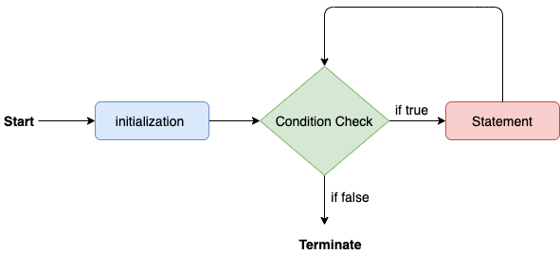

**Calculation.java:**

**public** **class** Calculation {

**public** **static** **void** main (String[] args) {

**int** sum = 0;

**for** (**int** j = 1; j<=10; j++) {

sum = sum + j;

}

System.out.println("The sum of first 10 natural numbers is " + sum);

}

}

s is 55

For-Each loop:

Java provides an enhanced for loop to traverse the data structures like array or collection. In the for-each loop, we don't need to update the loop variable. The syntax to use the for-each loop in java is given below.

**For** (datatype var : array_name/collection_name ){

//statements

}

**Calculation.java:**

**public** **class** Calculation {

**public** **static** **void** main(String[] args) {

String[] names = {"Java","C","C++","Python","JavaScript"};

System.out.println("Printing the content of the array names:\n");

**for**(String name:names) {

System.out.println(name);

}

}

}

**while loop:**

The while loop is also used to iterate over the number of statements multiple times. However, if we don't know the number of iterations in advance, it is recommended to use a while loop. Unlike for loop, the initialization and increment/decrement doesn't take place inside the loop statement in while loop. It is also known as the entry-controlled loop since the condition is checked at the start of the loop. If the condition is true, then the loop body will be executed; otherwise, the statements after the loop will be executed.

The syntax of the while loop is given below.

**while**(condition) {

//looping statements

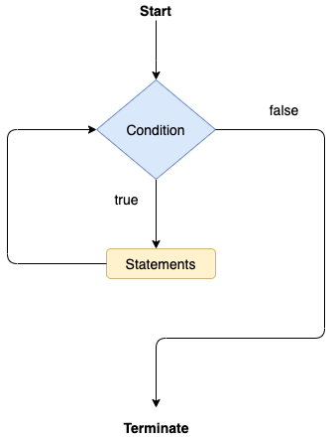}

**Calculation .java:**

**public** **class** Calculation {

**public** **static** **void** main(String[] args) {

**int** i = 0;

System.out.println("Printing the list of first 10 even numbers \n");

**while**(i<=10) {

System.out.println (i);

i = i + 2;

}

}

}

**Java do-while loop:**

The do-while loop checks the condition at the end of the loop after executing the loop statements. When the number of iterations is not known and we have to execute the loop at least once, we can use do-while loop. It is also known as the exit-controlled loop since the condition is not checked in advance. The syntax of the do-while loop is given below.

**do**

{

//statements

} **while** (condition);

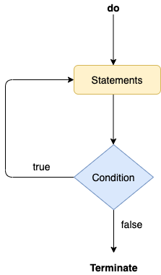

**Calculation.java:**

**public** **class** Calculation

{

**public** **static** **void** main(String[] args)

 {

**int** i = 0;

System.out.println("Printing the list of first 10 even numbers \n");

**do**

{

System.out.println(i);

i = i + 2;

} **while**(i<=10);

}

}

**Jump Statements**

Jump statements are used to transfer the control of the program to the specific statements. In other words, jump statements transfer the execution control to the other part of the program. There are two types of jump statements in Java, i.e.,

1. break
2. continue.

**Java break statement:**

As the name suggests, the break statement is used to break the current flow of the program and transfer the control to the next statement outside a loop or switch statement. However, it breaks only the inner loop in the case of the nested loop. The break statement cannot be used independently in the Java program, i.e., it can only be written inside the loop or switch statement.

**The break statement example with for loop** . Consider the following example in which we have used the break statement with the for loop.

**BreakExample.java**

**public** **class** BreakExample

{

**public** **static** **void** main(String[] args)

{

**for**(**int** i = 0; i<= 10; i++)

 {

System.out.println(i);

**If** ( i==6)

{

**break**;

}

}

}

}

**Java continue statement:**

Unlike break statement, the continue statement doesn't break the loop, whereas it skips the specific part of the loop and jumps to the next iteration of the loop immediately. Consider the following example to understand the functioning of the continue statement in Java.

**public** **class** ContinueExample

 {

**public** **static** **void** main(String[] args)

{

**for**(**int** i = 0; i<= 2; i++)

 {

**for** (**int** j = i; j<=5; j++)

 {

**if**(j == 4)

 {

**continue**;

}

System.out.println(j);

}

}

}

}

**Java Label Statement:**

1. Java does not have a general goto statement.
2. The statements break and continue in Java alter the normal control flow of control flow statements. They can use labels which are valid java identifiers with a colon.
3. Labeled blocks can only be used with break and continue statements.
4. Labaled break and continue statements must be called within its scope. We can not refer them outside the scope of labeled block.
5. The break statement immediately jumps to the end (and out) of the appropriate compound statement.
6. The continue statement immediately jumps to the next iteration (if any) of the appropriate loop.
7. A continue statement does not apply to a switch statement or a block statement, only to compound statements ( for-loop, while-loop, and do-while loop.)

outer:

for ( int i = 0; i < 10; i++)

{

inner:

for (int j = 10; j > 0; j--)

{

if ( i == j)

{

System.out.println(i);

break outer;

}

Else

{

System.out.println("-->>" + i ) ;

continue inner;

}

}

}

# JAVA ARRAYS --- 111

1. An array is a collection of similar type of elements store in the contiguous memory location.
2. **Java array** is an object which contains elements of a similar data type. Additionally, the elements of an array are stored in a contiguous memory location.
3. It is a data structure where we store similar elements. We can store only a fixed set of elements in a Java array.
4. Array in Java is index-based, the first element of the array is stored at the 0th index
5. In Java, array is an object of a dynamically generated class. Java array inherits the Object class, and implements the Serializable as well as Cloneable interfaces.
6. We can store primitive values or objects in an array in Java.
7. In array object create proxy object.

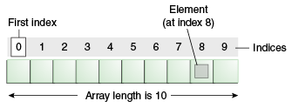

**Types of Arrays in java:**

1. Single Dimensional Array
2. Multidimensional Array

### Single Dimensional Array in Java:

**Syntax :** In java array create by object---

dataType[] arrayName = **new** datatype[size];

datatype[] arrayName = { data, data, data }

**Example :**

**class Testarray{**

**public static void main(String args[]){**

**int a[]=new int[5]; //declaration and instantiation**

**a[0]=10; //initialization**

**}**

**}**

60

### Multidimensional Array in Java:

**Syntax:**

dataType[][] arrayName = new datatype[size][];

**Example :**

int[][] arr=new int[3][3];

What is the class name of Java array?

In Java, an array is an object. For array object, a proxy class is created whose name can be obtained by

1. getClass().
2. getName()

method on the object.

**class** Testarray4{

**public** **static** **void** main(String args[]){

**int** arr[] = {4,4,5};

Class c = arr.getClass();

String name = c.getName();

System.out.println(name);

}

}

# String handling ---- 113

1. **String** is sequence of character. It is combination of character.
2. String is object in java
3. The process of performing operation over the string is called string handling.

String handle package

* 1. Java.lang.string
  2. Java.lang.StrignBuffer
  3. Java.lang.StrignBuilder
  4. Java.lang.StringTokenizer

Create object of string class:

**With new :**

Here memory allocation in heap memory area. Every time new create memory allocated in heap memory.   
 string s = new String (“shuvo”)

**Without new or string literal :**

In string literal, we just hold the string literal in variable. In java string literal treated as string object.

Whenever we creating the string object via literal it allocated memory in String constant poll.

Here same string value memory allocated for only one. Other share same memory.

String s = “shuvo”

String cannot modify:

String s = “ shuvo”’;

S= s.concat(“main”);

# Binding –91

Connecting a member call to the member definition is known as binding.

**Static Binding (compile Binding / early binding ).**

1. When type of the object is determined at compiled time(by the compiler), it is known as static binding.
2. If there is any private, final, or static method in a class, there is static binding.
3. Compile time binding done by compiler based on type of reference .
4. This is done using static, private and, final methods, constructor , initializers, method call via super keyword.

**class** Parent {

**int x = 444;**

**static int y = 20;**

}

**class** Child **extends** Parent {

**int x = 10;**

**static int y = 20;**

**static show(){**

**System.out.println(x)**

**}**

**}**

**class** Dynamic {

**public** **static** **void** main(String args[]) {

      Parent obj =  **new** Child();

      obj.show();  // invoke virtual

   }

}

**Dynamic Binding ( Runtime Binding / late binding );**

1. When member call gets their member definition at runtime it called runtime binding .
2. Runtime binding done by JVM based on type of object.
3. Non-static method is bind in dynamic.

**class** Parent extend Grand_Parent {

**int x = 444;**

}

**class** Child **extends** Parent {

**int x = 10**

**}**

**class** Dynamic {

**public** **static** **void** main(String args[]) {

      Parent obj =  **new** Child();   // invoke static

      obj.show();

   }

}

# OOP’s

Java is an Object-Oriented Language. Everything in Java is associated with classes and objects, along with its attributes and methods When we make software for real world, we can identify real world entity by object.

As a language that has the Object-Oriented feature, Java supports the following fundamental concepts –

1. Classes
2. Objects
3. Inheritance
4. Polymorphism
5. Encapsulation
6. Abstraction
7. Instance
8. Method
9. Message Passing

## CLASSES IN JAVA

1. A class is a blueprint of object.
2. Class is user defined data type.
3. A class is a group of objects which have common properties
4. Class declared by class key word.

**Example**

public class Dog {

String breed;

int age;

String color;

void barking() {

}

}

**A class in Java can contain:**

1. Attributes
2. Methods
3. Constructors
4. Blocks
5. Nested class
6. Interface

### **METHOD OF JAVA**

#### Main

1. A method is a block of code or collection of statements or a set of code grouped together to perform a certain task or operation.
2. Method creates in class.
3. It is used to achieve the reusability of code
4. We write a method once and use it many times.
5. We can also easily modify code using methods.

**The syntax to declare a method is:**

1. **Access Specifier:**
2. **Return Type**
3. **Method Name**
4. **Parameter List**
5. **Method Body**

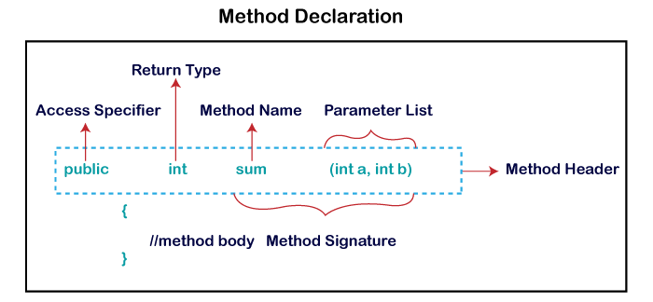

**Access Specifier/Modifier:**

Access specifier or modifier is the access type of the method. It specifies the visibility of the method. Java provides four types of access specifier:

1. **Public**: The method is accessible by all classes when we use public specifier in our application.
2. **Private**: When we use a private access specifier, the method is accessible only in the classes in which it is defined.
3. **Protected**: When we use protected access specifier, the method is accessible within the same package or subclasses in a different package.
4. **Default**: When we do not use any access specifier in the method declaration, Java uses default access specifier by default. It is visible only from the same package only.

**Return Type**:

It specifies what type of value a method returns for example if a method has an **int** return type then it returns an integer value. **If the method does not return a value, its return type** is void.

**Method Name**:

It is an identifier that is used to refer to the method in a program.

**Method body**:

It includes the programming statements that are used to perform some tasks. The method body is enclosed inside the **curly braces {}.**

There are two types of methods:

1. **User-defined Methods**: We can create our own method based on our requirements.
2. **Standard Library Methods**: These are built-in methods in Java that are available to use

**User-defined Method:**

The method written by the user or programmer is known as **a user-defined** method. These methods are modified according to the requirement.

**public static void findEvenOdd ( int num ){**

**If (num%2 == 0)**

**System.out.println(num+" is even");**

**else**

**System.out.println(num+" is odd");**

**}**

**Standard library Method**:

In Java, Method that is already defined in the Java class libraries is known as **standard library method** or **built-in method**. We can directly use these methods just by calling them in the program at any point. Some pre-defined methods are-

1. **length()**
2. **equals()**
3. **compareTo ()**
4. **sqrt()**

#### Other Method

**Methods in Java can also be classified into the following types:**

1. Static Method
2. Instance Method
3. Abstract Method
4. Factory Method

**Static Method:**

1. A method that belongs to a class rather than an instance of a class is known as a static method.
2. We can also create a static method by using the keyword **static** before the method name.
3. static method is called without creating an object.
4. It is invoked by using the class name.
5. Static method can’t use non static member
6. “this” and “super” keyword can’t be used here

**public class Display{**

**public static void main(String[] args){**

**show();**

**}**

**static void show(){**

**System.out.println("It is an example of static method.");**

**}**

**}**

**Instance Method:**

1. The method of the class is known as an **instance method**.
2. It is a **non-static** method defined in the class.
3. Before calling or invoking the instance method, it is necessary to create an object of its class.

**Example:**

**public class ABC {**

**public static void main(String [] args){**

**ABC obj = new ABC();**

**System.out.println ("The sum is: " + obj.add(12, 13) );**

**}**

**int s ;**

**public int add(int a, int b) {**

**s = a + b ;**

**return s ;**

**}**

**}  25**

There are two types of instance method:

1. **Accessor Method**
2. **Mutator Method**

**Accessor/Getter Method:**

The method(s) that reads the instance variable(s) is known as the accessor method. We can easily identify it because the method is prefixed with the word **get**. **It is also known as getters**. It returns the value of the private field. It is used to get the value of the private field. **Example:**

**public** **int** **getId**(){

**return** Id;

}

**Mutator/Setter Method:**

The method(s) read the instance variable(s) and modify the values. We can easily identify it because the method is prefixed with the word **set**. **It is also known as setters or modifiers**. It does not return anything. It accepts a parameter of the same data type that depends on the field. It is used to set the value of the private field. **Example,**

**public** **void** **setRoll**(**int** roll){

**this**.roll = roll;

}

Example of accessor and mutator method,

**public** **class** Student{

**private** **int** roll;

**public** **int** getRoll(){     //accessor method

**return** roll;

}

**public** **void** setRoll(**int** roll) { //mutator method

**this**.roll = roll;

}

**public** **void** display(){

System.out.println("Roll no.: "+roll);

}

}

**Abstract Method:**

1. The method that does not has method body is known as abstract method.
2. there is no need to provide the implementation code while declaring it.
3. It always declares in the abstract class.
4. It declares with abstract key word .

**Syntax**

**abstract** **void** method_name();

**Example**

**abstract** **class** Demo{ //abstract class

**abstract** **void** display();

}

**public** **class** MyClass **extends** Demo{

**void** display(){

System.out.println("Abstract method?");

}

**public** **static** **void** main(String args[]){

Demo obj = **new** MyClass();

obj.display();

}

}

method...

**Factory method**

It is a method that returns an object to the class to which it belongs. All static methods are factory methods.

**NumberFormat obj = NumberFormat.getNumberInstance();**

#### Java Method Parameters

Parameters: Parameter is the value that is defined in a functional block

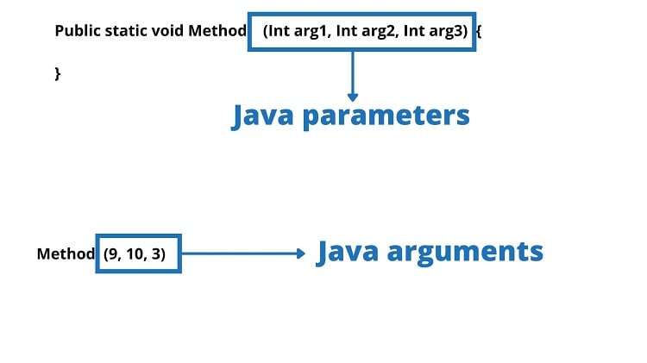Arguments: Argument is a variable whose value is passed into a function and is used whenever a function is called.

We can pass value in method as parameters.

**public class Main {**

**static void myMethod(String fname) {**

**System.out.println(fname + " Refsnes");**

**}**

**Static void add (int y, int x){**

**Int z = y + x;**

**System.out.println(z);**

**}**

**public static void main(String[] args) {**

**myMethod("Liam");**

**add(2,5);**

**}**

**}**

#### Method Overloading in Java

If a class has multiple methods having same name but different in parameters, it is known as Method Overloading. If we must perform only one operation, having same name of the methods increases the readability of the program.

**void func() { ... }**

**void func(int a) { ... }**

**float func(double a) { ... }**

**float func(int a, float b) { ... }**

**There are two ways to overload the method in java**

1. By changing number of arguments
2. By changing the data type(position parameter)

**1.Overloading by changing the number of parameters:**

**class** **MethodOverloading** {

**private static void** **display**(int a){

System.out.println("Arguments: " + a);

}

**private static void** **display**(int a, int b){

System.out.println("Arguments: " + a + " and " + b);

}

**public static void** **main**(String[] args) {

**display**(1);

**display**(1, 4);

}

}

**2. Method Overloading by changing the data type of parameters**

**class** **MethodOverloading** {

**private static void** **display**(int a){

System.out.println("Got Integer data.");

}

**private static void** **display**(String a){

System.out.println("Got String object.");

}

**private static void** **display**(int a, long b){

System.out.println("Arguments: " + a + " and " + b);

}

**private static void** **display**(long a, int b){ // position of parameter change

System.out.println("Arguments: " + a + " and " + b);

}

**public static void** **main**(String[] args) {

**display**(1);

**display**("Hello");

}

}

#### Method rules

1. In java method under method not possible.
2. Method should declare under a class.

**Class Test {**

**Static void sum (){**

**Int x = 10;**

**Int y = 10;**

**Int z = x + y;**

**}**

**Public static void main (String a[]){**

**sum ();**

**}**

**}**

1. Method should call with class. None static method cannot call directly.

**Class Test {**

**Static void sum (){**

**Int x = 10;**

**Int y = 10;**

**Int z = x + y;**

**}**

**Public static void main (String a[]){**

**Test t = new Test ();**

**t.sum()**

**}**

**}**

Main method in java

When we write a program, we write multiple code and class in program. But when we run the program, java do not know from where we run the code. So that we write an identifier class called main. If we write a main class in java program, java know that from here it run code. So, we write main class, and JVM run the main class. Main method is not pre-defined or user define. It is a contract between programmer and programing language.

### CONSTRUCTORS

1. A constructor in Java is a special method that is used to initialize objects.
2. The constructor is called when an object of a class is created.
3. It can be used to set initial values for object attributes.
4. It is not necessary to write a constructor for a class. It is because java compiler creates a default constructor
5. The name of the constructor should be the same as the class.
6. A Java constructor must not have a return type.

**Example:**

**public class Puppy {**

**public Puppy() {**

**}**

**}**

#### Types of Constructors:

1. No-Arg Constructor
2. Parameterized Constructor
3. Default Constructor

**No-argument constructor:**

1. A constructor that has no parameter is known as the No-argument or Zero argument constructor.

**class Main {**

**int i ;**

**private Main() {**

**i = 5;**

**System.out.println("Constructor is called");**

**}**

**public static void main(String[] args) {**

**Main obj = new Main();**

**System.out.println("Value of i: " + obj.i);**

**}**

**}**

**Parameterized Constructor:**

1. A constructor that has parameters is known as parameterized constructor.
2. If we want to initialize fields of the class with our own values, then use a parameterized constructor.

**class Main {**

**String languages;**

**Main(String lang) {**

**languages = lang;**

**System.out.println(languages + " Programming Language");**

**}**

**public static void main(String[] args) {**

**Main obj1 = new Main("Java");**

**Main obj2 = new Main("Python");**

**Main obj3 = new Main("C");**

**}**

**}**

**Default Constructor:**

If we do not create any constructor, the Java compiler automatically create a no-arg constructor during the execution of the program. This constructor is called default constructor.

Access modifier of constructor depends on class. If class public then constructor public.

**class GFG{**

**public static void main(String[] args){**

**GFG hello= new GFG();**

**}**

**}**

#### Construction overloading:

**We create multiple construction with different parameter.**

**class User{**

**User(){**

**System.out.println(“zero”);**

**}**

**User( int a ){**

**System.out.println(“one”);**

**}**

**User( int a, int b){**

**System.out.println(“two”);**

**}**

**public static void main(String[] args){**

**new User();**

**new User(12);**

**new User(177,54);**

**}**

**}**

### Initializer/ block

**Initializer** are those things which are used to initialized the data before object creation.

Depending on behavior they are two types of initializer.

**1. static block- object independent**

**2. Non static block (init block)- object dependent**

**Init-Block:**

1. **This** is anonymous block used to initialized the data before object creation and must be executed with respect to every object.

**Syntax:**

**{**

**……. code**

**}**

**Example:**

**class User{**

**User(){**

**System.out.println(“zeo”);**

**}**

**{**

**System.out.println(“hello “);**

**}**

**public static void main (String [] args){**

**new User ();**

**}**

**}**

1. It is object dependent. means object is necessary to execute the init block.
2. It is executing before constructor
3. It executes with respect to every constructor. Whereas constructor is specific.
4. You can write any logic inside init block.
5. After variable declaration we can create init block anywhere.

**class User{**

**int x ;**

**User(){**

**System.out.println(“zeo”);**

**}**

**{**

**System.out.println(“hello “);**

**}**

**public static void main (String [] args){**

**new User ();**

**}**

**}**

1. But Inside method init block treated as normal statement.

**class User{**

**int x ;**

**User(){**

**System.out.println(“zeo”);**

**}**

**{**

**System.out.println(“hello “);**

**}**

**public static void main (String [] args){**

**new User ();**

**{**

**System.out.println(“hello”)**

**}**

**}**

**}**

**8. Do not create same class object as same init block.**

**class User{**

**int x ;**

**User(){**

**System.out.println(“zeo”);**

**}**

**{**

**New User();**

**}**

**public static void main (String [] args){**

**new User ();**

**}**

**}**

#### How to work init block:

1. init block not called before the constructor called. It called when constructor called.
2. But when constructor create all init block paste at the top of every constructor during compilation time.

**class User{**

**int x ;**

**User(){**

**System.out.println(“init”);**

**System.out.println(“zeo”);**

**}**

**{**

// System.out.println(“init”);

**}**

**public static void main (String [] args){**

**new User ();**

**}**

**}**

1. With help of init block all value are initializing;

**class User{**

**int x = 10 ;**

**public static void main (String [] args){**

**new User ();**

**}**

**}**

**Actually happened:**

**class User{**

**int x ;  
{**

**x=10;**

**}**

**public static void main (String [] args){**

**new User ();**

**}**

**}**

### Various type of class ---87

Types of Classes:

* + - 1. Bean class
      2. Final Class
      3. Static Class
      4. Abstract Class
      5. Concrete Class
      6. POJO Class
      7. Inner Class
      8. Java Enum Class
      9. Java Reflection

Other Special Classes in Java:

1. Immutable Class
2. Singleton Class
3. Object Class
4. Wrapper Class

JAVA BEAN CLASS: --- 87

JavaBeans are classes that encapsulate many objects into a single object (the bean). It is a general purpose (It is not specific for any class) reusable piece of code.

1. It should be public.
2. It should have public default constructor
3. Its data member should be private.
4. This class should not extend any specific class or implements any interface (but must implement serializable).
5. It should have public setter and getter method.
6. Main method not use in java Bean class.

**Example:**

**import** java.io.Serializable;

**public** **class** Login **implements** Serializable {

**private** String name;

**public** **void** setName(String x) {

**this**.name = x;

}

**public** String getName() {

**return** name;

}

}

**Public class Test {**

**Login ob = new Login();**

**ob.setName(“shuvo”);**

**System.out.println(ob.getName());**

}

Syntax for setter methods:

1. It should be public in nature.
2. The return-type should be void.
3. The setter method should be prefixed with set.
4. It should take some argument i.e. it should not be no-arg method.

Syntax for getter methods:

1. It should be public in nature.
2. The return-type should not be void i.e. according to our requirement we have to give return-type.
3. The getter method should be prefixed with get.
4. It should not take any argument.

**POJO Class (plain old java) :**

A POJO (Plain Old Java Object) is a class containing only private member variables. Apart from the private member variables it only contains getter and setter methods used by these member variables.

A POJO class does not have its behavior. However, it may override some methods like equals or interfaces.

**Properties of POJO class:**

* POJO class must have a public getter and setter method.
* All the members or instance variables should be private.
* POJO class does not extend or implement classes or interfaces that are pre-specified.
* They do not contain annotations that are pre-specified.
* Does not have a constructor without any arguments (no-argument constructor).

**Given below is a Java Program that demonstrates the POJO class.**

|  |
| --- |
| //declare a POJO class  **class** POJO_Class {  **private** **int** daysOfWeek=7;         //private variable  **public** **int** getdaysOfWeek() {      //getter  **return** daysOfWeek;     }  **public** **void** setdaysOfWeek(**int** dow) {     //setter  **this**.daysOfWeek = dow;     }  }  **public** **class** Main {  **public** **static** **void** main(String args[]){        POJO_Class pojoDemo = **new** POJO_Class();   //instance of POJO class        System.out.println("Days of the week:" + pojoDemo.getdaysOfWeek());     }  } |

**Concreate class:**

When a class Implement an interface or extends any abstract class then it is called concreate class.

A concrete class is any normal class in a Java program. This class will not have any abstract methods. All the methods in the concrete class are completely implemented.

A concrete class can inherit from another class, even an abstract class or implement an interface. We can instantiate the concrete class and create its objects.

**A simple example of a concrete class is shown below.**

|  |
| --- |
| **public** **class** Main { // Concrete Class example  **static** **int** total(**int** val1, **int** val2) {  **return** val1 + val2;     }  **public** **static** **void** main(String args[]) {  **int** sum = total(100, 108);        System.out.println("Total of two integers: " + sum);     }  } |

### Java Singleton Class

In Java, Singleton is a design pattern that ensures that a class can only have one object.

To create a singleton class, a class must implement the following properties:

* Create a private constructor of the class to restrict object creation outside of the class.
* Create a private attribute of the class type that refers to the single object.
* Create a public static method that allows us to create and access the object we created. Inside the method, we will create a condition that restricts us from creating more than one object.

class SingletonExample {

private static SingletonExample singleObject;

private SingletonExample() {

// constructor of the SingletonExample class

}

public static SingletonExample getInstance() {

// write code that allows us to create only one object

// access the object as per our need

}

}

**Singletons can be used while working with databases. They can be used to create a connection pool to access the database while reusing the same connection for all the client**

Java enums

In Java, an enum (short for enumeration) is a type that has a fixed set of constant values. We use the enum keyword to declare enums.

Example:

enum Size {

SMALL, MEDIUM, LARGE, EXTRALARGE

}

class Main {

public static void main(String[] args) {

System.out.println(Size.SMALL);

System.out.println(Size.MEDIUM);

}

}

Java Enum with the switch statement

enum Size {

SMALL, MEDIUM, LARGE, EXTRALARGE

}

class Test {

Size pizzaSize;

public Test(Size pizzaSize) {

this.pizzaSize = pizzaSize;

}

public void orderPizza() {

switch(pizzaSize) {

case SMALL:

System.out.println("I ordered a small size pizza.");

break;

case MEDIUM:

System.out.println("I ordered a medium size pizza.");

break;

default:

System.out.println("I don't know which one to order.");

break;

}

}

}

class Main {

public static void main(String[] args) {

Test t1 = new Test(Size.MEDIUM);

t1.orderPizza();

}

}

**Methods of Java Enum Class:**

There are some predefined methods in enum classes that are readily available for use.

1. Java Enum ordinal()

The ordinal() method returns the position of an enum constant. For example,

ordinal(SMALL)

// returns 0

2. Enum compareTo()

The compareTo() method compares the enum constants based on their ordinal value. For example,

Size.SMALL.compareTo(Size.MEDIUM)

// returns ordinal(SMALL) - ordinal(MEDIUM)

3. Enum toString()

The toString() method returns the string representation of the enum constants. For example,

SMALL.toString()

// returns "SMALL"

4. Enum name()

The name() method returns the defined name of an enum constant in string form. The returned value from the name() method is final. For example,

name(SMALL)

// returns "SMALL"

5. Java Enum valueOf()

The valueOf() method takes a string and returns an enum constant having the same string name. For example,

Size.valueOf("SMALL")

// returns constant SMALL.

6. Enum values()

The values() method returns an array of enum type containing all the enum constants. For example,

Size[] enumArray = Size.value();

**Why Java Enums?**

In Java, enum was introduced to replace the use of int constants.

Suppose we have used a collection of int constants.

class Size {

public final static int SMALL = 1;

public final static int MEDIUM = 2;

public final static int LARGE = 3;

public final static int EXTRALARGE = 4;

}

Here, the problem arises if we print the constants. It is because only the number is printed which might not be helpful.

So, instead of using int constants, we can simply use enums. For example,

enum Size {

SMALL, MEDIUM, LARGE, EXTRALARGE

}

This makes our code more intuitive.enum provides compile-time type safety. If we declare a variable of the Size type. For example,

Size size;

Here, it is guaranteed that the variable will hold one of the four values. Now, If we try to pass values other than those four values, the compiler will generate an error.

**Java enum Constructor**

n enum class may include a constructor like a regular class. These enum constructors are either

private - accessible within the class  
or

package-private - accessible within the package

enum Size {

// enum constants calling the enum constructors

SMALL("The size is small."),

MEDIUM("The size is medium."),

LARGE("The size is large."),

EXTRALARGE("The size is extra large.");

private final String pizzaSize;

// private enum constructor

private Size(String pizzaSize) {

this.pizzaSize = pizzaSize;

}

public String getSize() {

return pizzaSize;

}

}

class Main {

public static void main(String[] args) {

Size size = Size.SMALL;

System.out.println(size.getSize());

}

}

Java enum Strings

e can get the string representation of enum constants using the toString() method or the name() method. For example,

enum Size {

SMALL, MEDIUM, LARGE, EXTRALARGE

}

class Main {

public static void main(String[] args) {

System.out.println("string value of SMALL is " + Size.SMALL.toString());

System.out.println("string value of MEDIUM is " + Size.MEDIUM.name());

}

}

Java Reflection

reflection allows us to inspect and manipulate classes, interfaces, constructors, methods, and fields at run time.

There is a class in Java named Class that keeps all the information about objects and classes at runtime. The object of Class can be used to perform reflection.

## Objects in Java

Let us now look deep into what are objects. If we consider the real-world, we can find many objects around us, cars, dogs, humans, etc. All these objects have a state and a behavior. If we consider a dog, then its state is - name, breed, color, and the behavior is - barking, wagging the tail, running. If you compare the software object with a real-world object, they have very similar characteristics. Software objects also have a state and a behavior. A software object's state is stored in fields and behavior is shown via methods. So in software development, methods operate on the internal state of an object and the object-to-object communication is done via methods.

### Creating an Object

1. A class provides the blueprints for objects. So basically, an object is created from a class.
2. In Java, the new keyword is used to create new objects.

**Syntax:**

Public class User{

String name;

Int id;

}

User shuvo = new User()

1. new keyword/ reference variable:

**Example:**

public class Puppy {

int age;

public Puppy(String name) {

System.out.println ("Name chosen is :" + name );

}

public int setAge(age ) {

this.age = age

}

public static void main(String []args) {

Puppy myPuppy = new Puppy( );

myPuppy.setAge( 2 );

System.out.println( "Variable Value :" + myPuppy.puppyAge );

}

}

2. method:

**class** Student{

**int** rollno;

 String name;

**void** insertRecord (**int** r, String n) {

  rollno=r;

  name=n;

 }

}

**class** TestStudent4{

**public** **static** **void** main(String args[]){

  Student s1=**new** Student();

  s1.insertRecord(111,"Karan");

 }

}

newInstance:

An object has three characteristics:

1. State: represents the data (value) of an object.
2. Behavior: represents the behavior (functionality) of an object such as deposit, withdraw, etc.
3. Identity: An object identity is typically implemented via a unique ID. The value of the ID is not visible to the external user. However, it is used internally by the JVM to identify each object uniquely.

### Memory allocation for object:

In java object are create by new keyword and construction method.

**Public class User {**

**String name;**

**Int id;**

**public static void main(String []args) {**

**User obj = new User( );**

**}**

**}**

1. new keyword allocates memory to the new objects at runtime.
2. Memory is allocated to the new objects from the heap memory.
3. The new keyword is followed by a call to a constructor, which instantiates the new object.
4. Construction is allocated the size of memory.

There are two type of memory allocation for object.

1. **STATIC (COMPILE TIME)**
2. When memory allocation occurred in compile time is called static or compile time memory allocation.
3. In compile time memory allocation not occurred. because if compile time memory allocation occurred then we not use this memory other computer.
4. Static memory are always referring via their name.

Int x = 10;

Here x is 10. When we need 10 we called x.

1. **DYNAMIC (RUN TIME)**
2. when memory is allocated in run time is called dynamic allocation. Dynamic memory is referring by pointer.
3. java does not support pointer explicitly. But implicitly it is used.

Reference variable: reference variable points the object address.

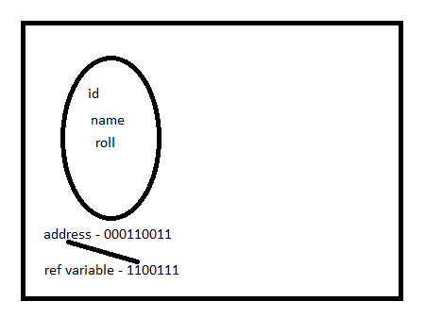

3. To use object multiple time we save reference variable in reference variable.

**Public class User {**

**String name;**

**Int id;**

**public static void main (String [] args) {**

**User obj = new User ();**

**Obj.name = “shuvo”;**

**Obj.id = 1323;**

**}**

**}**

### Anonymous Object:

1. An anonymous object is basically **a value that has been created but has no name.**
2. when creating an object in Java, you need to assign a name to the object.
3. But anonymous object only use when we create.

**Public class User {**

**String name;**

**Int id;**

**public static void main (String [] args) {**

**new User ();**

**}**

**}**

4. Every time anonymous object create every time new object create and new ref value create.

**Public class User {**

**String name;**

**Int id;**

**Public function show(){**

**System.out.println(name);**

**}**

**public static void main (String [] args) {**

**new User ().name=” shuvo”;**

**new User (). show ();**

**new User ().id=12364;**

**}**

**}**

**5. if we** use null as object reference then garbage collection deletes the memory for object which do not have ref vary.

6. one obj reference id give other object reference id. Here object

### Type of object Reference variable:

Here we use ref variable as class type. Because

**Public class User {**

**String name;**

**Int id;**

**public static void main (String [] args) {**

**User obj = new User ();**

**System.out.println(obj)**

**}**

**}**

## Relation/Reusability of class code -- 70

1. Reusability is a mechanism which facilitates you to reuse the fields and methods of the existing class when you create a new class.
2. You can use the same fields and methods already defined in the previous class.
3. Inheritance (IS-A),
4. Association (HAS-A)

### IS-a relationship:

1. Whenever one class inherits another class, it is called an IS-A relationship.
2. It is the process of acquiring the property and behavior of parent class (base, super) into new class called child class (sub class)
3. IS-A relationship can simply be achieved by extending an interface or class by using extend keyword.

Example:

public class Address {

String city;

int road;

}

public class Person extends Address {

Address add = new Address ();

add.city = “dhaka”;

}

### HAS-A relationship:

1. When an object of one class is created as a data member inside another class, it is called Has-A relationship.
2. Association is a relation between two separate classes which establishes through their Objects.

There are two types of Has-A relationship

1. Composition(Strong)
2. Aggregation(Weak)

Example:

**public class Address {**

**String city;**

**int road;**

**}**

**public class Person { // Person has-a Address.**

**Address add = new Address ();**

**add.city = “dhaka”;**

**}**

**Aggregation:**

In other words, two aggregated objects have their own life cycle but one of the objects has an owner of Has-A relationship and child object cannot belong to another parent object.

For example, a library has s**tudents**. If the **library** is destroyed, students will exist without library.

**Composition(Strong):**

Composition can be described as when one class which includes another class, is dependent on it in such a way that it cannot functionally exist without the class which is included.

For example, a class Car cannot exist without Engine, as it won't be functional anymore.

## Java – Inheritance ---71

1. Inheritance can be defined as the process where one class acquires the properties (methods and fields) of another.
2. With the use of inheritance, the information is made manageable in a hierarchical order.
3. The class which inherits the properties of other is known as subclass/Child Class (derived class, child class) and the class whose properties are inherited is known as superclass /Parent Class (base class, parent class).
4. **extends** is the keyword used to inherit the properties of a class. Following is the syntax of extends keyword.

**Syntax:**

**class A {**

**………….**

**}**

**class Sub extends A {**

**………….**

**}**

**Example:**

**class Parent {**

String name;

**public void eat() {**

System.out.println("I can eat");

}

}

**class Child extends Parent** {

public void display () {

System.out.println( name);

}

**public static void main(String[] args) {**

**Child ob = new Child();**

ob.name = "shuvo";

ob.display();

ob.eat();

}

}

### Types of Inheritance

There are various types of inheritance as demonstrated below.

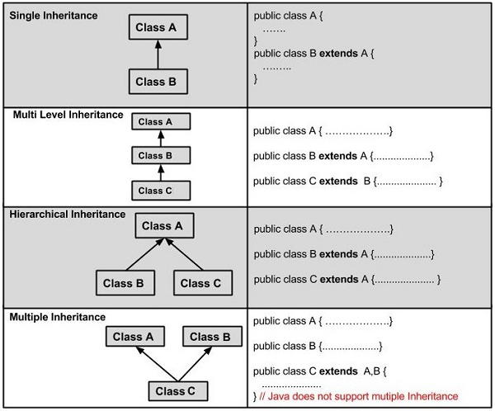

### Data Hiding/ super ---74

1. When in program, the name of parent class data variable and the name of child class data variable are same, then program take child class data as main variable, this concept is called data hiding.
2. Whenever data hiding is done always preference goes to child class data.

**class Parant {**

**String name;**

**}**

**class Child extends Parant {**

**String name;**

**public void show () {**

**System.out.println( name );**

**}**

**public static void main(String[] args) {**

**Child obj = new Child ();**

**obj.show();**

**}**

}

1. If we want access the parent class data variable, we can do it by **super** keyword.
2. The super keyword in java is a reference variable that is used to refer parent class objects.
3. Super only call the immediate parent data not parent of parent .
4. Super cannot use inside static context

**class Parant {**

**String name;**

**}**

**class Child extends Parant {**

**String name;**

**public void show () {**

**System.out.println(super.name);**

**}**

**public static void main (String [] args) {**

**Child obj = new Child ();**

**obj.show();**

**}**

}

### How to memory allocate for inherence ---74

1. If we see in inheritance parent class not create object. So how can allocate memory for parent class.
2. In java all parent class memory is allocated in child class memory location when child class object was created.

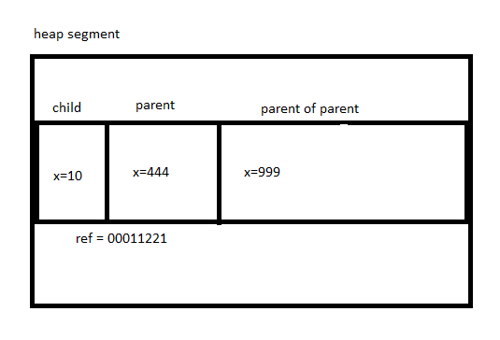

### Upcasting:

1. Upcasting is a type of object typecasting in which a child object is typecasted to a parent class object.
2. By using the Upcasting, we can easily access the variables and methods of the parent class to the child class.
3. Here, we don't access all the variables and the method. We access only some specified variables and methods of the child class.
4. Upcasting is also known as Generalization and Widening.
5. With upcasting we hold child object in parent reference variable .

**Example:**

**class** Grand_Parent{

**int x = 9999;**

}

**class** Parent extend Grand_Parent {

**int x = 444;**

}

**class** Child **extends** Parent {

**int x = 10**

**public void show (Parent obj, Grand_Parent obj ) {**

**System.out.println(obj.x); // output : 4444**

**System.out.println(x); //output : 10**

**System.out.println(obj.x); // output : 9999**

**}**

}

**class** UpcastingExample{

**public** **static** **void** main(String args[]) {

      Parent obj =  **new** Child();

      obj.show(obj, obj );

   }

}

Downcasting :

Upcasting is a type of object typecasting in which a Parent object is typecasted to a child class object.

**class** Parent {

**int x = 444;**

}

**class** Child **extends** Parent {

**int x = 10**

**display(){**

**System.out.println(“dkfj”);**

**}**

**public** **static** **void** main(String args[]) {

Parent obj =  **new** Child();

Child ob2 = (Child) obj;

   }

}

### Method overriding:

1. if the same method is defined in both the superclass and the subclass, then the method of the subclass class overrides the method of the superclass. This is known as method overriding.
2. The method must have the same name as in the parent class
3. The method must have the same parameter as in the parent class.
4. There must be an IS-A relationship (inheritance).
5. Method overrides access modifier always weaker to stronger.

**Example:**

**class** Vehicle{

**void** run(){

System.out.println("Vehicle is running");

}

}

**class** Bike2 **extends** Vehicle{

**void** run(){

System.out.println("Bike is running safely");

}

**public** **static** **void** main(String args[]){

Bike2 obj = **new** Bike2();

 obj.run();

  }

}

#### Covariant Return: -----78

1. we can method override with change return type (it is come in after jdk 1.5). it is called covariant type.
2. Both class method must have return type is reference type whereas primitive data type not allowed.
3. The classes which used as return type they also must have relation of parent and child.

**class** Vehicle{

**void run(){**

System.out.println("Vehicle is running");

}

}

**class** Bike2 **extends** Vehicle{

**Vehicle  run(){**

System.out.println("Bike is running safely");

}

**public** **static** **void** main(String args[]){

Bike2 obj = **new** Bike2();

 obj.run();

  }

}

#### Method hiding: ----------------78

When static method, of parent class override in static method of child class is called method hiding.

**class** Vehicle{

**void static run(){**

System.out.println("Vehicle is running");

}

}

**class** Bike2 **extends** Vehicle{

**Vehicle static  run(){**

System.out.println("Bike is running safely");

}

**public** **static** **void** main(String args[]){

Bike2 obj = **new** Bike2();

 obj.run();

  }

}

### Rules of constructor of inheritance

1. Before executing any child class constructor firstly execute its immediate parent **class default constructor** implicitly.(**parameterize cannot execute**)
2. Compiler added super at the top of every constructor.
3. this and super both cannot stay same constructor .
4. for data initialize the of parent, this rule creates.
5. If parameterize constructor called then super should called.

**Class K{**

**K(){**

System.out.prinln(“constructor K”);

}

**Class L extends K{**

**L(){**

System.out.prinln(“constructor L”);

}

}

**Public class B extends L{**

**B(){**

System.out.prinln(“constructor B”);

}

}

## Java Encapsulation ----- 87

1. Encapsulation is the process of wrapping the data member and member function into a single unit called class.
2. Encapsulation are used for data hiding.
3. Java bean class provided 100% encapsulation.

**class** Account {

**private** **long** acc_no;

**private** String name ,password;

**public** **void** **setName(String name) {**

**this**.name = name;

}

**public** **String getName()** {

**return** name;

}

**public** **void** **setPassword() {**

**this**.password = password;

}

**public** **String** **getPassword ()** {

**return password;**

}

}

**public** **class** TestEncapsulation {

**public** **static** **void** main(String[] args) {

Account user=**new** Account();

**user.setName(“shuvo”);**

**user.setPassword(“123”);**

System.out.println(**user.getName()+"** "+**acc.getPassword** ());

}

}

## Java Polymorphism ---96

1. Polymorphism means more than one form. the same entity (method or operator or object) can perform different operations in different scenarios.
2. A person at the same time can have different characteristics. Like a man at the same time is a father, a husband, an employee. So, the same person possesses different behavior in different situations. This is called polymorphism.
3. Polymorphism always achieve on method not on data member.
4. We can perform polymorphism in java by method overloading and method overriding.

In Java polymorphism is mainly divided into two types:

1. Compile-time Polymorphism
2. Runtime Polymorphism

### Compile-time Polymorphism

1. Compile Time Polymorphism is also known as Static Polymorphism.
2. Furthermore, the call to the method is resolved at compile-time.
3. Compile-Time polymorphism is achieved through Method Overloading, constructor overloading .

**public class Addition {**

**void sum(int a, int b) {**

**int c = a+b;**

**System.out.println(“ Addition of two numbers :” +c);**

**}**

**void sum(int a, int b, int e) {**

**int c = a+b+e;**

**System.out.println(“ Addition of three numbers :” +c);**

**}**

**public static void main(String[] args) {**

**Addition obj = new Addition();**

**obj.sum ( 30,90);**

**obj.sum(45, 80, 22);**

**}**

**}**

### Runtime Polymorphism:

1. It is also known as Dynamic Method Dispatch.
2. It is a process in which a function call to the overridden method is resolved at Runtime.
3. This type of polymorphism is achieved by Method **Overriding** and **Upcasting**.

**We can achieve polymorphism in Java using the following ways:**

1. [Method Overriding](https://www.programiz.com/java-programming/method-overriding)
2. [Method Overloading](https://www.programiz.com/java-programming/method-overloading)
3. Operator Overloading

Method Overriding

If subclass (child class) has the same method as declared in the parent class, it is known as **method overriding in Java**.

**class Animal {**

**public void move() {**

**System.out.println("Animals can move");**

**}**

}

**class Dog extends Animal {**

**public void move() {**

**System.out.println("Dogs can walk and run");**

**}**

**}**

**public class TestDog {**

**public static void main(String args[]) {**

**Animal a = new Animal(); // Animal reference and object**

**Animal b = new Dog(); // Animal reference but Dog object**

**a.move(); // runs the method in Animal class**

**b.move(); // runs the method in Dog class**

**}**

**}**

**Rules for Method Overriding**

1. The argument list should be the same as that of the overridden method.
2. The return type should be the same or a subtype of the return type declared in the original overridden method in the superclass.
3. The access level cannot be more restrictive than the overridden method's access level. For example: If the superclass method is declared public then the overriding method in the sub class cannot be either private or protected.
4. Instance methods can be overridden only if they are inherited by the subclass.
5. A method declared final cannot be overridden.
6. A method declared static cannot be overridden but can be re-declared.
7. If a method cannot be inherited, then it cannot be overridden.
8. A subclass within the same package as the instance's superclass can override any superclass method that is not declared private or final.
9. A subclass in a different package can only override the non-final methods declared public or protected.
10. Constructors cannot be overridden.

## Final keyword --- 101

It is the keyword that used to restrict the user.

It is used in variable method, class

**Final class :**

When a class is declared with final keyword, it is called a final class. A final class cannot be extended(inherited).

final class A{

// methods and fields

}

class B extends A{

// COMPILE-ERROR ! Can't subclass A

}

**Final method :**

When a method is declared with final keyword, it is called a final method. A final method cannot be overridden.

**class A{**

**final void m1(){**

**System.out.println("This is a final method.");**

**}**

**}**

**class B extends A{**

**void m1() {**

**// Compile-error! We cannot override**

**System.out.println("Illegal!");**

**}**

**}**

**Final variable :**

1. If you make any variable as final, you cannot change the value of final variable(It will be constant).
2. This also means that you must initialize a final variable.
3. A final variable that is not initialized at the time of declaration is known as blank final variable.
4. If the final variable is a reference, this means that the variable cannot be re-bound to reference another object, but the internal state of the object pointed by that reference variable can be changed i.e. you can add or remove elements from the final array or final collection.

**class** GFG {

**final** **int** THRESHOLD = 5;

**final** **int** CAPACITY;

**final** **int**  MINIMUM;

**static** **final** **double** PI = 3.141592653589793;

**static** **final** **double** EULERCONSTANT;

    {

         CAPACITY = 25;

    }

**static**{

         EULERCONSTANT = 2.3;

    }

**public** GFG(){

         MINIMUM = -1;

    }

}

## Abstract class in Java ---102

Abstraction :

1. Abstraction is a process of hiding the implementation details and showing only functionality to the user.
2. it shows only essential things to the user and hides the internal details.

Example : IF sending SMS where you type the text and send the message. You don't know the internal processing about the message delivery.

There are two ways to achieve abstraction in java

1. Abstract class (0 to 100%)
2. Interface (100%)

Two types of abstraction :

1. Java Abstract Class
2. Java Abstract Method

**Abstract class in Java:**

1. An abstract class must be declared with an abstract keyword.
2. Abstract classes may or may not contain abstract methods.so that it is (0-100)% abstract method.
3. if a class has at least one abstract method, then the class must be declared abstract.
4. We cannot create objects of abstract classes.(If a class is declared abstract, it cannot be instantiated(object) ).
5. To use an abstract class, you must inherit it from another class.
6. If you inherit an abstract class, you must override to all the abstract methods in It.

**Example:**

**public abstract class Employee {**

**private int number;**

**public Employee(String name) {**

this.name = name;

}

**public double computePay() {**

System.out.println("Inside Employee computePay");

}

}

**public class Main {**

**public static void main(String [] args) {**

Employee e = new Employee("Shuvo”);

e.computerPay();

}

}

**Abstract Method in Java**

1. A method which is declared as abstract and does not have implementation is known as an abstract method.
2. An abstract method contains a method name, but no method body in abstract class.
3. Instead of curly braces, an abstract method will have a semi colon (;)
4. abstract method cannot private , static, and final.
5. if any method declared in abstract class, then extends class must be override the method.
6. If abstract method declared in class and class is not declared abstract class then, class will be abstract class.
7. Abstract method can be create construction.

Example:

**abstract class Bike{**

**abstract void run();**

**}**

**class Honda4 extends Bike{**

**void run(){**

**System.out.println("running safely");**

**}**

**public static void main(String args[]){**

**Bike obj = new Honda4();**

**obj.run();**

**}**

**}**

Why abstract method cannot create object, cannot user final, static, private : 103

Generic method :

1. Generic method has only declaration
2. It not has anybody ,
3. Its body create by other class when it is implemented

## Interface in Java ----- 103

1. The interface in Java is a mechanism to achieve abstraction.
2. An **interface in Java** is a blueprint of a class
3. We use the implements keyword to implement an interface.
4. An interface does not contain any constructors.
5. An interface is not extended by a class; it is implemented by a class.
6. An interface can extend multiple interfaces.
7. When a class implements an interface then class must override all the method of interface with public access privilege otherwise class has been abstracted.
8. We cannot create objects of an interface.
9. An interface is implicitly abstract. You do not need to use the abstract keyword while declaring an interface.
10. Each method in an interface is also implicitly abstract, so the abstract keyword is not needed.
11. Methods in an interface are implicitly public.
12. Since Java 8, we can have default and static methods in an interface.
13. Since Java 9, we can have private methods in an interface.

**Syntax:**

interface <interface_name>{

     // declare constant fields

}

**Example** :

interface Player{

final int id = 10;

int move();

}

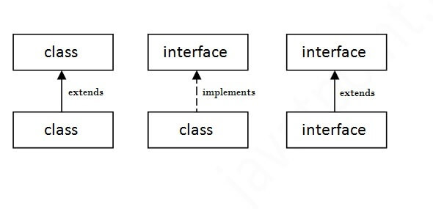

Multiple inheritance in Java by interface

If a class implements multiple interfaces, or an interface extends multiple interfaces, it is known as multiple inheritance.

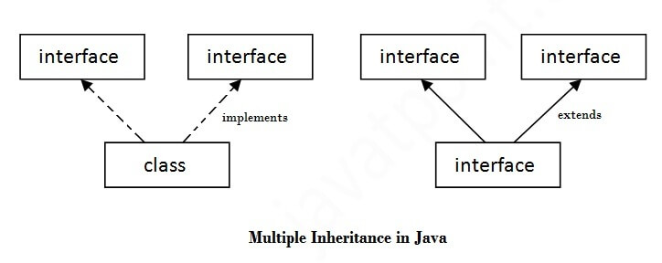

**interface** Printable{

**void** print();

}

**interface** Showable{

**void** show();

}

**class** A7 **implements** Printable,Showable{

**public** **void** print() { System.out.println("Hello"); }

**public** **void** show() { System.out.println("Welcome"); }

**public** **static** **void** main(String args[]){

A7 obj = **new** A7();

obj.print();

obj.show();

 }

}

# Package of java

# Java Exceptions --- 115

An exception is an unexpected event that occurs during program execution. It affects the flow of the program instructions which can cause the program to terminate abnormally.

An exception can occur for many reasons. Some of them are:

1. Invalid user input
2. Device failure
3. Loss of network connection
4. Physical limitations (out of disk memory)
5. Code errors
6. Opening an unavailable file

**Java Exception hierarchy:**

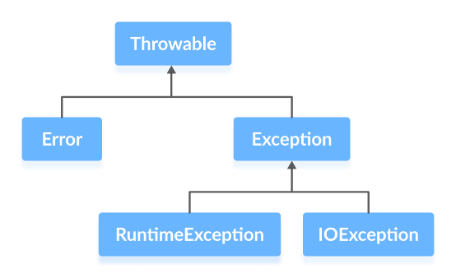

### Errors:

Errors represent irrecoverable conditions such as

1. Java virtual machine (JVM) running out of memory,
2. memory leaks,
3. stack overflow errors,
4. library incompatibility,
5. infinite recursion, etc.

Errors are usually beyond the control of the programmer, and we should not try to handle errors.

### Exceptions

Exceptions can be caught and handled by the program. When an exception occurs within a method, it creates an object. This object is called the exception object. It contains information about the exception such as the name and description of the exception and state of the program when the exception occurred.

**Java Exception Types:**

The exception hierarchy also has two branches:

1. Runtime Exception
2. IO Exception.

1. Runtime Exception

A runtime exception happens due to a programming error. They are also known as unchecked exceptions. These exceptions are not checked at compile-time but run-time. Some of the common runtime exceptions are:

1. **Improper use of an API - IllegalArgumentException**
2. **Null pointer access (missing the initialization of a variable) - NullPointerException**
3. **Out-of-bounds array access - ArrayIndexOutOfBoundsException**
4. **Dividing a number by 0 – Arithmetic Exception**

2. IO Exception:

An IOException is also known as a checked exception. They are checked by the compiler at the compile-time and the programmer is prompted to handle these exceptions. Some of the examples of checked exceptions are:

1. Trying to open a file that doesn’t exist results in FileNotFoundException
2. Trying to read past the end of a file.

## Java Exception Handling: --121

1. try...catch block
2. finally block
3. throw and throws keyword

try...catch:

The try...catch block in Java is used to handle exceptions and prevents the abnormal termination of the program.

**try {**

int divideByZero = 5 / 0;

System.out.println("Rest of code in try block");

}

**catch (ArithmeticException e) {**

System.out.println("ArithmeticException => " + e.getMessage());

}

finally block:

finally, block is always executed no matter whether there is an exception or not. The finally block is optional. And, for each try block, there can be only one finally block.

The basic syntax of finally block is:

**try {**

**//code**

**}**

**catch (ExceptionType1 e1) {**

**// catch block**

**}**

**finally {**

**// finally block always executes**

**}**

throw and throws :

The throw statement allows you to create a custom error.

When

**class ThrowExcep{**

**static void fun() {**

**try {**

**throw new NullPointerException("demo");**

**}**

**catch(NullPointerException e) {**

**System.out.println("Caught inside fun().");**

**throw e; // rethrowing the exception**

**}**

    }

**public static void main(String args[]) {**

        try{

            fun();

        }

        catch(NullPointerException e){

            System.out.println("Caught in main.");

        }

**}**

**}**

# FILE/IO handling

Java I/O (Input and Output) is used to process the input and produce the output.

Stream:

A stream can be defined as a sequence of data. There are two kinds of Streams −

1. Byte Stream
2. Character Stream

Here is a hierarchy of classes to deal with Input and Output streams.

Byte Stream:

Byte stream is used to read and write a single byte (8 bits) of data.

1. [Java InputStream Class](https://www.programiz.com/java-programming/inputstream)
2. [Java OutputStream Class](https://www.programiz.com/java-programming/outputstream)

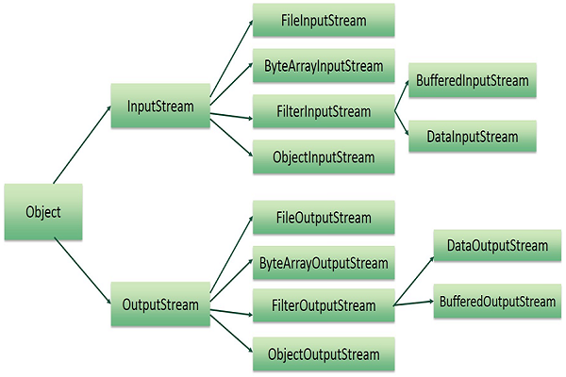

* \

Character Stream:

Character stream is used to read and write a single character of data. Java **Character** streams are used to perform input and output for 16-bit Unicode.

All the character stream classes are derived from base abstract classes Reader and Writer.

1. FileReader
2. FileWriter

File handling methods:

Method Type Description

canRead() Boolean Tests whether the file is readable or not

canWrite() Boolean Tests whether the file is writable or not

createNewFile() Boolean Creates an empty file

delete() Boolean Deletes a file

exists() Boolean Tests whether the file exists

getName() String Returns the name of the file

getAbsolutePath() String Returns the absolute pathname of the file

length() Long Returns the size of the file in bytes

list() String[] Returns an array of the files in the directory

mkdir() Boolean Creates a directory

File class :

1. file
2. fileReader
3. fileWrite
4. fileinputstream
5. fileoutputstream
6. bufferinputstream
7. bufferoutputstream

# Generics

1. We can hold only a single type of objects in generics. It does not allow to store other objects.
2. There is no need to typecast the object.
3. It is checked at compile time so problem will not occur at runtime.
4. We can generic in all interface of collection.

Generic class

# Lambda Expression

When we implement interface with anomious

Syntax:

( argument )->{ body }

# Collections Framework

## Collection framework

1. The Collection in Java is a framework that provides an architecture to store and manipulate the group of objects.
2. Java Collections can achieve all the operations that you perform on a data such as searching, sorting, insertion, manipulation, and deletion.

**Hierarchy of Collection Framework**

Let us see the hierarchy of Collection framework. The **java.util** package contains all the classes and

Interfaces for the Collection framework.

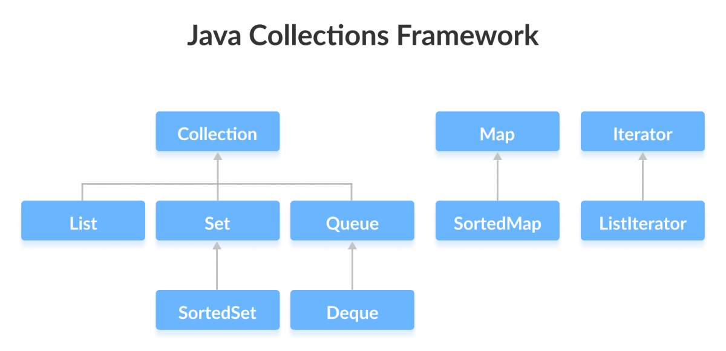

**Java collection framework has multiple interface**

1. Collection interface
2. Iterator interface
3. Enumeration interface
4. Map iterator interface

## Collection Interface

1. The Collection interface is the root interface of the collections framework hierarchy.
2. Java does not provide direct implementations of the Collection interface but provides implementations of its sub interfaces like List, Set, and Queue.

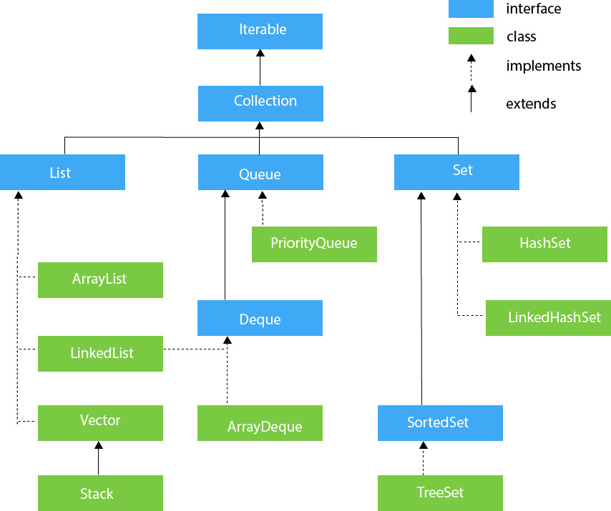

Subinterfaces of the Collection Interface

1. List Interface
2. Queue Interface
3. Set Interface

**Methods of Collection:**

The Collection interface includes various methods that can be used to perform different operations on objects. These methods are available in all its sub interfaces.

1. add() - inserts the specified element to the collection.
2. size() - returns the size of the collection.
3. set() : To change elements of the arraylist.
4. remove() - removes the specified element from the collection.
5. iterator() - returns an iterator to access elements of the collection.
6. addAll() - adds all the elements of a specified collection to the collection.
7. removeAll() - removes all the elements of the specified collection from the collection.
8. clear() - removes all the elements of the collection.
9. isEmpty()- This method returns true if this collection contains no elements.
10. max()--This method is used to return the maximum value present in the collection.
11. toArray() --This method is used to return an array containing all the elements in this collection.

### List:

1. In Java, the List interface is an ordered collection that allows us to store and access elements sequentially.
2. It extends the Collection interface.
3. Since List is an interface, we cannot create objects from it.
4. we must import **java.util.List** package in order to use List

In order to use functionalities of the List interface, we can use these classes:

1. ArrayList class
2. LinkedList class
3. Vector class
4. Stack class

#### ArrayList Class:

1. The ArrayList class of the Java collections framework provides the functionality of resizable-arrays.
2. ArrayList provides us with dynamic arrays in Java
3. Creating an ArrayList Before using ArrayList, we need to import **the java.util.ArrayList** package first.

**Syntax:**

**ArrayList <Type> arrayList= new ArrayList<>();**

**Example:**

import java.util.ArrayList;

**class Main {**

**public static void main(String[] args)** {

**ArrayList<String> user= new ArrayList<>();**

**user. add("shuvo");**

**user.add("korim");**

**for (String p : user) {**

**System.out.print(p);**

**System.out.print(", ");**

**}**

**}**

**}**

**Constructor of arrayList :**

1. **ArrayList():**This constructor is used to build an empty array list. If we wish to create an empty ArrayList with the name arr, then, it can be created as:

ArrayList arr = new ArrayList();

1. **ArrayList(Collection c):** This constructor is used to build an array list initialized with the elements from the collection c. Suppose, we wish to create an ArrayList arr which contains the elements present in the collection c, then, it can be created as:

ArrayList arr = new ArrayList(c);

1. **ArrayList(int capacity):** This constructor is used to build an array list with initial capacity being specified. Suppose we wish to create an ArrayList with the initial size being N, then, it can be created as:

ArrayList arr = new ArrayList(N);

#### Java LinkedList class:

The LinkedList class of the Java collections framework provides the functionality of the linked list data structure (doubly linkedlist). Each element in a linked list is known as a node.

It consists of 3 fields:

1. Prev - stores an address of the previous element in the list. It is null for the first element
2. Next - stores an address of the next element in the list. It is null for the last element
3. Data - stores the actual data

**Creating a Java LinkedList:**

LinkedList<Type> linkedList = new LinkedList<>();

#### Java Vector:

1. The Vector class is an implementation of the List interface that allows us to create resizable-arrays like the ArrayList class.
2. Vector is synchronized.
3. Java Vector contains many legacy methods that are not the part of a collection’s framework.
4. In vector capacity increase double.

**Creating a Vector:**

Vector<Type> vector = new Vector<>();

Example:

**class Main {**

**public static void main(String[] args) {**

**Vector<String> animals= new Vector<>();**

**animals.add("Dog");**

**animals.add("Horse");**

**animals.add("Cat");**

**Iterator<String> iterate = animals.iterator();**

**while(iterate.hasNext()) {**

**System.out.print( iterate.next() );**

**System.out.print(", ");**

}

}

}

**Constructor of vector :**

**vector() -** It constructs an empty vector with the default size as 10.

**vector(int initialCapacity) -** It constructs an empty vector with the specified initial capacity and with its capacity increment equal to zero.

**vector(int initialCapacity, int capacityIncrement) -** It constructs an empty vector with the specified initial capacity and capacity increment.

**Vector( Collection<? extends E> c) -** It constructs a vector that contains the elements of a collection c.

**Methods of Vector**

1. Add Elements:

* add(element) - adds an element to vectors
* add(index, element) - adds an element to the specified position
* addAll(vector) - adds all elements of a vector to another vector

1. Access Vector Elements

* get(index) - returns an element specified by the index
* iterator() - returns an iterator object to sequentially access vector elements

1. Remove Vector Elements

* remove(index) - removes an element from specified position
* removeAll() - removes all the elements
* clear() - removes all elements. It is more efficient than removeAll()

1. other

* set() changes an element of the vector
* size() returns the size of the vector
* toArray() converts the vector into an array
* toString() converts the vector into a String
* contains() searches the vector for specified element and returns a boolean result

#### Java Stack Class :

The Java collections framework has a class named Stack that provides the functionality of the stack data structure. The Stack class extends the Vector class.

Creating a Stack:

In order to create a stack, we must import the java.util.Stack package first. Once we import the package, here is how we can create a stack in Java.

Stack<Type> stacks = new Stack<>();

Stack Methods:

1. [empty()](https://www.javatpoint.com/java-stack#empty)
2. [push(E item)](https://www.javatpoint.com/java-stack#push)
3. [pop()](https://www.javatpoint.com/java-stack#pop)
4. [peek()](https://www.javatpoint.com/java-stack#peek)
5. [search(Object o)](https://www.javatpoint.com/java-stack#search)

### Java Queue Interface

The Queue interface of the Java collections framework provides the functionality of the queue data structure. It extends the Collection interface.

**Methods of Queue:**

1. add()
2. offer()
3. element()
4. peek()
5. remove()

Java PriorityQueue class:

The PriorityQueue class provides the functionality of the heap data structure.

**Creating PriorityQueue:**

In order to create a priority queue, we must import the java.util.PriorityQueue package. Once we import the package, here is how we can create a priority queue in Java.

**PriorityQueue<Integer> numbers = new PriorityQueue<>();**

Other PriorityQueue Methods:

1. contains(element)
2. size()
3. toArray()

### Java Deque Interface:

The Deque interface of the Java collections framework provides the functionality of a double-ended queue. It extends the Queue interface.

Classes that implement Deque-----

1. [ArrayDeque](https://www.programiz.com/java-programming/arraydeque)
2. [LinkedList](https://www.programiz.com/java-programming/linkedlist)

Methods of Deque:

Since Deque extends the Queue interface, it inherits all the methods of the Queue interface.

1. addFirst()
2. addLast()
3. offerFirst()
4. offerLast()
5. getFirst()
6. getLast()
7. peekFirst()
8. peekLast()
9. removeFirst()
10. removeLast()
11. pollFirst()
12. pollLast()

### java LinkedList:

**---------- Discuss Before -----------**

### Java ArrayDeque:

Interfaces implemented by ArrayDeque. The ArrayDeque class implements these two interfaces:

1. [Java Queue Interface](https://www.programiz.com/java-programming/queue)
2. [Java Deque Interface](https://www.programiz.com/java-programming/deque)

**Creating ArrayDeque:**

ArrayDeque<Type> animal = new ArrayDeque<>();

### Java Map Interface:

The Map interface of the Java collections framework provides the functionality of the map data structure. A map contains values on the basis of key, i.e. key and value pair. Each key and value pair is known as an entry. A Map contains unique keys.

Java Map Hierarchy:

The hierarchy of Java Map is given below:

1. HashMap
2. EnumMap
3. LinkedHashMap
4. WeakHashMap
5. TreeMap

These classes are defined in the collections framework and implement the Map interface.

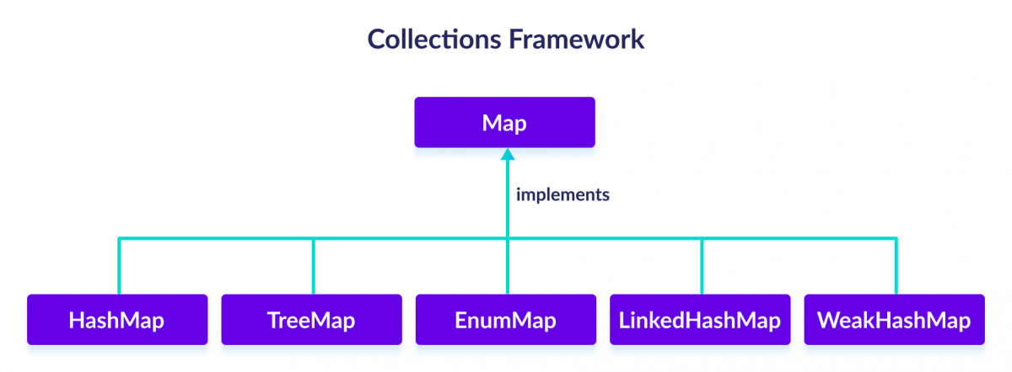

Interfaces that extend Map

The Map interface is also extended by these subinterfaces:

1. SortedMap
2. NavigableMap
3. ConcurrentMap

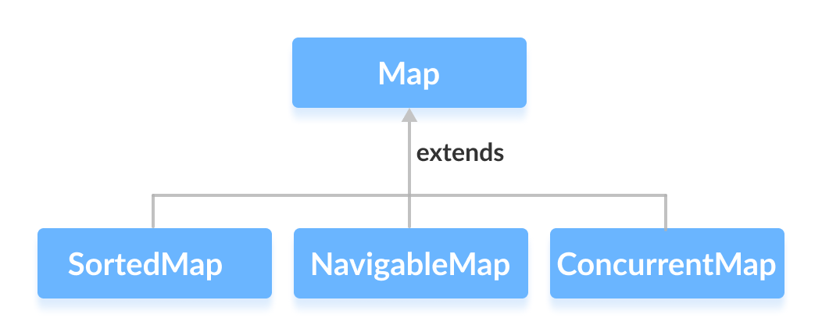

How to use Map?

In Java, we must import the java.util.Map package in order to use Map. Once we import the package,

Map<Key, Value> numbers = new HashMap<>();

## Iterator interface

1. The Iterator interface of the Java collections framework allows us to access elements of a collection.
2. Iterators are used to retrieve elements one by one.
3. Iterator is one of the Java cursors.
4. It is a universal iterator as we can apply it to any Collection object.
5. It supports only Forward direction iteration

**Syntax:**

Iterator itr = array_name.iterator();

**Example:**

**public class JavaIteratorExample {**

**public static void main(String[] args)   {**

**ArrayList<String> cityNames = new ArrayList<String>();**

**cityNames.add("Delhi");**

**cityNames.add("Mumbai");**

**Iterator iterator = cityNames.iterator();**

**while ( iterator.hasNext() )**

**System.out.print( iterator.next() + " ");**

**}**

**}**

**Methods of Iterator:**

1. hasNext() - returns true if there exists an element in the collection
2. next() - returns the next element of the collection
3. remove() - removes the last element returned by the next()
4. forEachRemaining() - performs the specified action for each remaining element of the collection

### listIterator interface

1. It has a sub interface Iterator.
2. This means it allows us to iterate elements of a list in both the direction.
3. It is a java iterator that is used to traverse all types of lists including ArrayList, Vector, LinkedList, Stack.
4. There is **no current element** in ListIterator. Its cursor always lies between the previous and next elements.

**Syntax:**

ListIterator itr = array_name.listIterator();

**Example:**

**public class GFG {**

**public static void main(String[] args)    {**

**List<String> names = new LinkedList<>();**

**names.add("learn");**

**names.add("from");**

**ListIterator<String> listIterator  = names.listIterator();**

**while (listIterator.hasNext()) {**

           System.out.println( listIterator.next() );

        }

**while (listIterator.hasPrevious()) {**

            System.out.println( listIterator.previous() );

        }

    }

}

**Methods of ListIterator**

1. hasNext() - returns true if there exists an element in the list
2. next() - returns the next element of the list
3. nextIndex() returns the index of the element that the next() method will return
4. previous() - returns the previous element of the list
5. previousIndex() - returns the index of the element that the previous() method will return
6. remove() - removes the element returned by either next() or previous()
7. set() - replaces the element returned by either next() or previous() with the specified element

# Thread --- 126

Task:

1. A task is a piece of work that needs to be done.
2. A task is a set of program instructions that are loaded in memory.
3. Task in Operating System may be synonymous with process.
4. If a printer prints a document, it is said to perform a printing task.

Process:

The process is a program under execution. A program can be defined as a set of instructions. So that we can say , Active state of program is process. When we execute a program, it remains on the hard drive of our system and when this program comes into the main memory it becomes a process.   
The process can be present on a hard drive, memory, or CPU.

Thread:

A thread is a lightweight sub-process, the smallest unit of processing. Multiprocessing and multithreading, both are used to achieve multitasking.

Thread creates by ---

1. Extending thread class
2. Association of thread class (Runnable interface )

# Synchronization ---141